******FY 2019**

**PRESIDENT’S EMERGENCY PLAN FOR AIDS Relief**

**HIV DATA AUDIT**

**October 2019**

This publication was produced at the request of the United States Agency for International Development. It was prepared independently by a Technical Team under the USAID/Nigeria Monitoring, Evaluation & Learning Activity.

**FY 2019**

**President’s Emergency Plan for AIDS Relief**

**HIV DATA AUDIT**

Submitted to:

Mr. Akinyemi Atobatele, M&E Manager HIV/TB Team, USAID/Nigeria

Copied:

Dr. Chidimma Anyanwu, COR, USAID/Nigeria

Ms. Beth Brownson, Monitoring, Evaluation and Learning Program Officer, USAID/Nigeria

Mr. Christopher Gaukler, M&E Fellow\Social Solutions International, Expanding Monitoring and Evaluation Capacities (MECap)

Submitted by:

Paul DeLucco

Chief of Party MEL Activity

USAID Contractor DevTech Systems, Inc.

Report Submitted: October 2019

Cover Page Photo Credit: <https://imarticus.org/top-3-reasons-to-include-data-analytics-in-a-financial-audit/>

**Disclaimer:**

The views expressed in this report are those of the Audit Team and do not necessarily reflect the views of USAID, the Government of Nigeria, or any other organization or person associated with this project.

**Contents**

LIST OF TABLES 5

LIST OF FIGURES 5

ACRONYMS 6

EXECUTIVE SUMMARY 8

1. BACKGROUND 14

1.1 INTRODUCTION 14

1.2 OBJECTIVES OF THE data audit 15

1.3 PERIOD OF THE Data audit 15

1.4 INDICATORS to be audited 15

1.4.1 HTS_TST (Including hts_tst_pos) 15

1.4.2 hts_INDEX (Including hts_iNDEX_pos) 15

1.4.3 Tx_new 16

1.4.4 Tx_curr 16

1.4.5 TX_PVLS (NUMERATOR AND DENOMINATOR) 16

1.4.6 Number of HIV POSITIVE IN OVc program (ovc_hivstat_pos) 16

2. METHODOLOGY 17

2.1 SAMPLING METHODOLOGY FOR SITE SELECTION 17

2.1.1 Inclusion Criteria for FHI 360 Sites 18

2.1.2 Exclusion Criteria for FHI 360 Sites 18

2.2 SAMPLE SIZE FOR FHI 360 SITES 18

2.3 AUDIT PROCESS FOR KEY INDICATORS 18

2.3.1 HTS_TST (INCLUDING hts_tst_pos) AND hts_index (including hts_index_pos) 18

2.3.2 Tx_new 18

2.3.3 Tx_curr 19

2.3.4 TX_PLVS (NUMERATOR AND DENOMINATOR) 19

2.3.5 Number of HIV POSITIVE IN OVc program (OVC_HIVSTAT Positives) 19

2.4 DATA AUDIT TOOL 19

2.5 DATA ANALYSIS 20

2.6 DATA AUDIT TEAM 21

2.6.1 Consultants (STTA) 21

2.6.2 Orientation for Data Audit Consultants 22

2.7 SITE VISIT schedule 22

3. FINDings – Concurrence Rates 23

3.1 FHI 360/SIDHAS 23

3.1.1 HTS_TST (Including hts_tst_pos) and hts_index 23

3.1.2 Tx_new 25

3.1.3 Tx_curr 26

3.2 HEARTLAND ALLiANCE INTERNATIONAL/IMHIPP 27

3.2.1 HTS_TST (INCLUDING hts_tst_pos) AND hts_index 27

3.2.2 Tx_new 30

3.2.3 Tx_curr 30

3.2.4 TX_PLVS (Numerator and Denominator) 31

3.3 ARFH LOPIN 1 32

3.3.1 Number of HIV Positive in OVc Program (OVC_HIVSTAT Positives) 32

3.4 StC Steer 33

3.4.1 Number of HIV Positive in OVc Program (OVC_HIVSTAT Positives) 33

3.5 HIFASS LOPIN 3 34

3.5.1 Number of HIV Positive in OVc Program (OVC_HIVSTAT Positives) 34

4. FINDings – Data quality issues 35

4.1 FHI 360/SIDHAS 35

4.1.1 Cross Cutting Issues Across All fhi 360/sidhas Sites 35

4.1.2 Ituk Mbang Methodist General Hospital 36

4.1.3 Uyo Base Primary Health Care 36

4.1.4 Mercy Hospital 36

4.1.5 Ikot Ekpene General Hospital 36

4.1.6 Oron Operational Base Primary Health Centre 37

4.1.7 Enwang Primary Health Centre 37

4.1.8 Ikot Ebak Poly Clinic 37

4.1.9 University Teaching Hospital 37

4.1.10 Oron General Hospital (Iquita) 38

4.1.11 Etim Ekpo General Hospital 38

4.1.12 Ukana Cottage Hospital 38

4.1.13 Etinan General Hospital 39

4.1.14 Ibiono Handsmaid Hospital 39

4.1.15 Nung Udoe Primary Health Centre 39

4.1.16 Ukana Iba St Joseph's Rehabilitation Center 39

4.1.17 Okobo General Hospital 39

4.1.18 Ikot Ekpene Primary Health Centre 40

4.2 HEARTLAND ALliaNCE INTERNATIONAL/IMHIPP 40

4.2.1 Cross Cutting Issues Across All hai/imhipp oss 40

4.2.2 Uyo OSS 40

4.2.3 Ikot Ekpene oss 41

4.2.4 Eket oss 41

4.3 OVC PARTNERS 41

4.3.1 Cross Cutting Issues Across All Three OVC Partners 41

4.3.2 ARFH LOPIN 1 42

4.3.3 STC STEER 42

4.3.4 HIFASS LOPIN 3 43

5. RECOMMENDATIONS 43

5.1 usaid NIGERIA 43

5.2 FHI 360 43

5.3 HAI 44

5.4 OVC PARTNERS 44

6. CONSTRAINTS AND LIMITATIONS 44

7. ANNEX 45

7.1 PEPFAR MER 2.0 INDICATOR REFERENCE GUIDE VERSION 2.3 SEPTEMBER 2018 45

7.2 HIV Data Audit results 45

7.3 PICTURES SHOWING DATA QUALITY ISSUES AT FHI 360 SITES 45

**LIST OF TABLES**

Table 1: USAID/Nigeria IP Organizations Implementing the Surge HIV Epidemic Control Response in Akwa Ibom State 14

Table 2: Key Indicators for Data Audit by IP and IM 17

Table 3: Data Audit Site Visit Locations and Dates 22

**LIST OF FIGURES**

Figure 1: Concurrence Rates for HTS_TST by FHI360 SIDHAS Health Facilities 25

Figure 2: Concurrence Rates for HTS_TST Positives by FHI360 SIDHAS Health Facilities 25

Figure 3: Concurrence Rates for HTS_INDEX by FHI360 SIDHAS Health Facilities 26

Figure 4: Concurrence Rates for HTS_INDEX Positives by FHI360 SIDHAS Health Facilities 26

Figure 5: Concurrence Rates for TX_NEW by FHI360 SIDHAS Health Facilities 27

Figure 6: Concurrence Rates for TX_CURR by FHI360 SIDHAS Health Facilities 27

Figure 7: Percentage of Validated Active Clients on LAMIS by FHI360 SIDHAS Health Facilities 28

Figure 8: Concurrence Rates for HTS_TST by HAI IMHIPP LGAs 29

Figure 9: Concurrence Rates for HTS_TST Positives by HAI IMHIPP LGAs 29

Figure 10: Concurrence Rates for HTS_INDEX by HAI IMHIPP LGAs 30

Figure 11: Concurrence Rates for HTS_INDEX Positives by HAI IMHIPP LGAs 30

Figure 12: Concurrence Rates for TX_NEW by HAI IMHIPP Treatment Sites 31

Figure 13: Concurrence Rates for TX_CURR by HAI IMHIPP Treatment Sites 31

Figure 14: Percentage of Validated Active Clients on LAMIS by HAI IMHIPP Treatment Sites 32

Figure 15: Concurrence Rates for TX_PVLS by HAI IMHIPP Treatment Sites 32

Figure 16: Concurrence Rates (NOMIS) OVC_HIVSTAT Positives for ARFH LOPIN 1 LGAs 33

Figure 17: Concurrence Rates (VC folders) OVC_HIVSTAT Positives for ARFH LOPIN 1 LGAs 33

Figure 18: Concurrence Rates (NOMIS) OVC_HIVSTAT Positives for STC STEER LGAs 34

Figure 19: Concurrence Rates (VC folders) OVC_HIVSTAT Positives for STC STEER LGAs 34

Figure 20: Concurrence Rates (NOMIS) OVC_HIVSTAT Positives for HIFASS LOPIN 3 LGAs 35

Figure 21: Concurrence Rates (VC folders) OVC_HIVSTAT Positives for HIFASS LOPIN 3 LGAs 35

Figure 22: Picture Showing Age Outliers in the OVC HIVSTATPOS FY 2019 Q3 Line List From the IP 44

Figure 23: Incomplete documentation on the ART Care Cards 46

Figure 24: Pharmacy order forms without the signature of the pharmacist who dispensed the ART 47

Figure 25: Alterations on pharmacy order forms without an authorizing signature to validate the changes 47

Figure 26:Date alterations on the pharmacy order form and client folder to reflect the status of an active client with no authorizing signature to validate the changes (2/7/19 changed to 2/6/19) 48

Figure 27:Temporary folders seen at some health facilities (22 were sighted in GH Oron) 48

**ACRONYMS**

ARFH Association for Reproductive Health

ART Anti-Retroviral Therapy

CBO Community Based Organization

COP Country Operational Plan

EMR Electronic Medical Records

ESM Enhanced Site Management

FHI 360 Family Health International 360

FY Fiscal Year

HAI Heartland Alliance International

HAT HIV/AIDS Team

HIFASS Health Initiative for Safety and Stability in Africa

HIV Human Immunodeficiency Virus

HIV/AIDS Human Immunodeficiency Virus/Acquired Immunodeficiency Syndrome

HTS HIV Testing Services

HTS_TST HIV Testing PEPFAR MER indicator

IM Implementing Mechanism

IMHIPP Integrated MARPs HIV Prevention Program

IP Implementing Partner

KP Key Population

LAMIS Lafiya Management Information System

LIS Laboratory Information System

LGA Local Government Area

LOPIN 1 Local OVC Partners in Nigeria 1

LOPIN 3 Local OVC Partners in Nigeria 3

MARPs Most at Risk Populations

M&E Monitoring and Evaluation

MEL The Monitoring, Evaluation, and Learning Activity (DevTech Systems, Inc. Nigeria)

MER Monitoring, Evaluation and Reporting

NAIIS Nigeria AIDS Indicator and Impact Survey

NOMIS National OVC Management information System

OGAC Office of the United States Global AIDS Coordinator

OVC Orphans and Vulnerable Children

OVC_SERV Orphans and Vulnerable Children Served (PEPFAR MER Indicator)

OSS One Stop Shop

PEPFAR President’s Emergency Plan for AIDS Relief

PIRS Performance Indicator Reference Sheet

PVLS Percentage of Viral Load Suppression PEPAFAR MER Indicator

SIDHAS Strengthening Integrated Delivery of HIV/AIDS Services

STC Save the Children

STEER Systems Transformed for Empowered Action and Enabling Responses for Vulnerable Children and Families

STTA Short Term Technical Assistance

TX Treatment

TX_NEW HIV Treatment PEPFAR MER indicator

TX_CURR HIV Treatment PEPFAR MER indicator

USAID United States Agency for International Development

VC Vulnerable Children

VL Viral Load

**EXECUTIVE SUMMARY**

**BACKGROUND:** The United States President’s Emergency Plan for AIDS Relief (PEPFAR) Nigeria is implementing a ‘surge’ response to the HIV epidemic in Akwa Ibom state based on the data generated through the recent Nigeria Acquired Immunodeficiency Syndrome (AIDS) Indicator and Impact Survey-NAIIS. The ‘surge’ commenced implementation in Akwa Ibom state in April 2019 by various Implementing Mechanisms (IMs) of various USAID/Nigeria Implementing Partner (IP) organizations. These IP organizations have reported performance data based on the quarterly reporting requirement of both the Office of the Global AIDS Coordinator (OGAC) and USAID/Nigeria. Hence, the HIV/AIDS Team (HAT) of USAID/Nigeria conducted an audit to verify reported data, provide quality baseline data for the surge implementation going forward, identify potential challenges to data quality and develop action plans to improve identified gaps.

The IP organizations and corresponding IMs audited are Family Health International 360 (FHI 360)/ Strengthening Integrated Delivery of HIV/AIDS Services (SIDHAS); Heartland Alliance International (HAI)/ Integrated MARPs HIV Prevention Program (IMHIPP); Save the Children Nigeria (StC)/ Systems Transformed for Empowered Actions and Enabling Responses (STEER); Health Initiative for Safety and Stability in Africa (HIFASS)/ Local Orphan and Vulnerable Children [OVC] Partners in Nigeria 3 (LOPIN 3); and Association for Reproductive and Family Health (ARFH)/ Local OVC Partners in Nigeria 1 (LOPIN 1).

The indicators audited for FHI 360/SIDHAS and HAI/IMHIPP include HTS_TST (including HTS_TST_POS), HTS_INDEX (including HTS_INDEX_POS), TX_NEW, TX_CURR and TX_PVLS (Numerator and Denominator). The OVC_HIVSTAT_POS indicator was audited for StC/STEER, ARFH/LOPIN 1 and HIFASS/LOPIN 3. The audit validated data generated between April 1, 2019 and June 30, 2019 (Fiscal Year [FY] 2019 Quarter 3).

**METHODOLOGY:**

Site Selection: Sites selected and visited for the audit include: All sites that reported data on the selected indicators for HAI/IMHIPP (three One Stop Shops [OSS]); All 14 reporting Local Government Areas [LGAs]) for StC/STEER; All eight (8) reporting LGAs for ARFH/LOPIN 1; and all eight (8) reporting LGAs for HIFASS/LOPIN 3. For FHI 360/SIDHAS, data from sites with FY Q3 reported TX_CURR equal to or greater than (=/>) 250 were included in the audit; representing 86 percent of the total 42,523 TX_CURR reported (36, 301) and representing data from 42 health facilities. Only data from 17 health facilities accounting for reported TX_CURR for 25,627 clients (70 percent of 36,301 and 60 percent of 42,523) were audited due to logistics reasons.

Audit Process:

The audit process for the**HTS_TST (including HTS_TST_POS) and HTS_INDEX (including HTS_INDEX_POS)** indicators included a review of data reported by the IP/IM to USAID for FY 2019 Q3 against a recount of data in the National HIV/AIDS Testing Services (HTS) registers.

The audit process for **TX_NEW** included a review of data reported by the IP/IM to USAID for FY 2019 Q3 against verified data in the client folders. The review was dependent on the line list provided by the IP/IM of all ***‘new’*** clients for the period of review.

The audit process for **TX_CURR** included a review of data reported by the IP/IM to USAID for FY 2019 Q3 against verified data in the client folders and data available in the site electronic medical records (Lafiya Management Information System - LAMIS). The review was dependent on the line list provided by the IP/IM of all **‘*active’*** clients for the period of review.

The audit process for **TX_PVLS** included a review of data reported by the IP/IM to USAID for FY 2019 Q3 against verified data in the client folders and viral load registers. The review was dependent on the line list provided by the IP/IM of all **‘*active’*** clients for the period of review.

The audit process for **OVC_HIVSTAT_POS** included a review of indicator data available at the site electronic medical records (National OVC Management Information System – NOMIS) for the period under review against verified data in the client folders. The review was dependent on the line list provided by the IP/IM of OVC_HIVSTAT_POS clients for the period of review.

Data Audit Tools: Two (2) customized Excel tools were used for the data audit exercise; one for the HIV treatment sites and one for the OVC partners.

Data Analysis**:** Data entered in the data audit tools were cleaned, processed and analyzed using the tools. The results were presented using charts and tables within the audit tool. Further analysis was conducted using Microsoft Excel on the summaries from the data audit tools. Data validation concurrence rate (CR) was used to determine accuracy of validated data in comparison with data reported to USAID for each indicator and site. For a specific site, CR is the ratio of reported data to recounted /validated data for each indicator. CR greater than 100 percent indicates that indicator data reported to USAID was over-reported. CR less than 100 percent indicates that indicator data reported to USAID was under-reported. A +/- five (5) percent margin of error is deemed acceptable for each indicator and used to assess the suitability of the audited indicator(s) for decision making.

Data Audit Team: The data audit team comprised of staff of the MEL Activity and twenty-nine (29) short-term technical assistance (STTA) consultants contracted by the MEL Activity to support the data audit exercise. HAT members and MEL Activity staff provided supervisory and technical oversight to the consultants during the site visits. The data audit team visited the sites between July 31 and August 10, 2019.

**KEY FINDINGS (FHI 360):**

Data Quality Issues: The data quality issues observed at the FHI 360 supported sites include:

* Inconsistency in the methodology for data collection and reporting of the viral load test date.
* No SOP provided to guide the movement and reporting of received viral load results.
* The most recent Lab request forms containing the viral load results were not always contained within the folders.
* The most recent pharmacy order forms were not filed within the folders, resulting in validation of indicator data using the pharmacy daily worksheet. Some of the folders with missing pharmacy order forms could not be validated using the pharmacy daily worksheet because the client records were not found in the worksheet.
* Incomplete documentation of client information on the ART care card: age at ART start, sex and ART start date.
* Varying documentation of client information (age at ART start, sex and ART start dates) upon review of the ART care card, IP’s line list and the LAMIS/EMR.
* Complete absence of ART care cards within some client folders.
* Alterations were sighted on some pharmacy order forms without an authorizing signature to validate the changes.
* Pharmacy order forms were sighted without the signature of the pharmacist who dispensed the ART.
* The records/folders of some clients reported active within the period of review were not sighted for review at the time of visit (folders not found by facility staff).
* The records of some clients reported active within the period of review were found inactive upon review of source documents (52 cases seen at Etinan GH).
* Records of active clients not in the IP’s line list were seen, reviewed and captured within the data audit tool (111 active clients were seen at Enwang PHC).
* During the mop-up site visits, folders previously pending review/not seen during the first visit to the site, were presented for review as new folders containing a few patient monitoring and management (PMM) forms for clients that have been active for a considerable number of years. These folders were termed ‘temporary folders’ (Ituk Mbang Methodist Hospital, UUTH and Oron GH).
* Multiple ART care cards were seen within the same folders, often with varying age and ART start dates recorded on each of the cards (Ikot Ekpene GH).

FHI 360 Concurrence Rates (CR):

***HTS_TST:*** Ten (10) of the 17 health facilities had concurrence rates within the acceptable variance range of +\- five (5) percent. Three (3) of the 7 health facilities with concurrence rates outside the acceptable variance range significantly over-reported, while the remaining four (4) significantly under-reported indicator data.

***HTS_TST_POS:*** Ten (10) of the 17 health facilities had concurrence rates within the acceptable variance range of +\- five (5) percent. Four (4) of the 7 health facilities with concurrence rates outside the acceptable variance range significantly over-reported, while the remaining three (3) significantly under-reported indicator data.

***HTS_INDEX:*** Two (2) of the 17 health facilities had concurrence rates within the acceptable variance range of +\- five (5) percent. Eleven (11) of the 15 health facilities with concurrence rates outside the acceptable variance range significantly over-reported, while the remaining four (4) significantly under-reported indicator data.

***HTS_INDEX_POS:*** Eleven (11) of the 17 health facilities had concurrence rates within the acceptable variance range of +\- five (5) percent. Three (3) of the 6 health facilities with concurrence rates outside the acceptable variance range significantly over-reported, while the remaining three (3) significantly under-reported indicator data.

***TX_NEW:*** Eleven (11) of the 17 health facilities had concurrence rates within the acceptable variance range of +\- five (5) percent.Three (3) of the 6 health facilities with concurrence rates outside the acceptable variance range significantly over-reported, while the remaining three (3) significantly under-reported indicator data.

***TX_CURR:*** All the health facilities had concurrence rates within the acceptable variance range of +\- five (5) percent except Enwang Primary Health Centre with significantly under-reported indicator data (94 percent).

***Percentage of Validated Active Clients on LAMIS:*** Only five (5) health facilities had all validated active clients in LAMIS.The other twelve (12) health facilities had missing active client details which could not be found among the active client list on LAMIS.

**KEY FINDINGS (HAI):**

Data Quality Issues: The data quality issues observed at the HAI supported sites include:

* Inconsistency in the methodology for data collection and reporting of the viral load test date across OSS.
* No SOP to guide the movement and reporting of received viral load results within the OSS after delivery to the sites by the logistics riders.
* The outdated version of the HTS register (with outdated age disaggregation by sex) was in use at all the HAI OSS sites visited, increasing the likelihood for error in age disaggregation reporting for the HTS indicator.
* The records/folders of a few clients reported active within the period of review were not sighted for review at the time of visit (5 of 6,450).
* The records of some clients reported active within the period of review were found inactive upon review of source documents (33 of 6,450)
* Records of some clients not in the IP’s line list were seen, reviewed and captured within the data audit tool (61 cases).

HAI Concurrence Rates (CR):

***HTS_TST:*** Thirteen (13) of the 27 LGAs had concurrence rates within the acceptable variance range of +\- five (5) percent. Nine (9) of the 14 LGAs with concurrence rates outside the acceptable variance range significantly over-reported, while the remaining five (5) significantly under-reported indicator data.

***HTS_TST_POS:*** Eleven (11) of the 27 LGAs had concurrence rates within the acceptable variance range of +\- five (5) percent. Thirteen (13) of the 16 LGAs with concurrence rates outside the acceptable variance range significantly over-reported, while the remaining three (3) significantly under-reported indicator data.

***HTS_INDEX:*** Ten (10) of the 27 LGAs had concurrence rates within the acceptable variance range of +\- five (5) percent. Eleven (11) of the 17 LGAs with concurrence rates outside the acceptable variance range significantly over-reported, while the remaining six (6) significantly under-reported indicator data.

***HTS_INDEX_POS:*** Four (4) of the 27 LGAs had concurrence rates within the acceptable variance range of +\- five (5) percent. Thirteen (13) of the 23 LGAs with concurrence rates outside the acceptable variance range significantly over-reported, while the remaining ten (10) significantly under-reported indicator data.

***TX_NEW:*** The two (2) reporting treatment sites had concurrence rates within the acceptable variance range of +\- five (5) percent.

***TX_CURR:*** The two (2) reporting treatment sites had concurrence rates within the acceptable variance range of +\- five (5) percent.

***Percentage of Validated Active Clients on LAMIS:*** All the validated active clients had records in LAMIS at the Eket KP OSS. Only 98 percent of the validated active clients had records in LAMIS at the Uyo Heartland Alliance Community Centre.

***TX_PVLS:*** The concurrence rate for the TX_PVLS numerator indicator disaggregate for Uyo Heartland Alliance Community Centre was within the acceptable variance range of +\- five (5) percent; and outside the acceptable variance range for Eket KP OSS. The two treatment sites had concurrence rates outside the acceptable variance range for the TX_PVLS denominator indicator disaggregate.

**KEY FINDINGS (OVC SURGE IPS):**

Cross-Cutting Data Quality Issues: Cross-cutting data quality issues observed at the all the OVC surge IP sites include:

* The reporting interface of NOMIS appears to be defective because data with varying information on the HIV_STAT_POS indicator were generated via two different reporting sections of the NOMIS at the time of visit.
* The ART treatment status was not always updated on the service forms. Treatment status had to be established by the presence of the returned copy of the client referral form from a treatment facility.
* Various interfaces on NOMIS capture dates differently. Both the mm/dd/yy and dd/mm/yy date formats are in use on the NOMIS, increasing the likelihood for data entry errors relating to date last served and other dates that are captured on the system.
* Discrepancies were observed between the age and sex documented in the folders and the age and sex documented on the IP’s line list and NOMIS due to transcription errors during data entry.
* E.g. a male client as seen within the folder can be captured in error as female on the NOMIS or vice versa; and a seven-month-old client was seen captured as seven years old on the NOMIS.

**ARFH Specific Findings:**

* All the LGAs had concurrence rates within the acceptable variance range of +\- five (5) percent when the line list summary data was compared against entries on NOMIS. All the LGAs had concurrence rates within the acceptable variance range of +\- five (5) percent when the line list summary data was compared against VC folders entries.

**StC Specific Findings:**

* Upon review of relevant source documents, 115 clients (from all 14 LGAs) reported as OVC HIVSTAT POS within the period of review were enrolled and served in July 2019.
* Two (2) of the 14 LGAs had concurrence rates within the acceptable variance range of +\- five (5) percent when the line list summary data was compared against entries on NOMIS.
* All the twelve (12) LGAs with concurrence rates outside the acceptable variance range significantly over-reported indicator data. Two (2) of the 14 LGAs had concurrence rates within the acceptable variance range of +\- five (5) percent when the line list summary data was compared against VC folders entries. All the twelve (12) LGAs with concurrence rates outside the acceptable variance range significantly over-reported indicator data.

**HIFASS Specific Findings:**

* The unique IDs of VC within the same household were being used interchangeably (seen within the folder and on NOMIS). Hence, data for a particular VC can be seen captured on the NOMIS or service form using the unique ID of the sibling.
* Over-reporting in NOMIS was due to data entries in NOMIS outside the 3-month review period.
* All the LGAs had concurrence rates within the acceptable variance range of +\- five (5) percent when the line list summary data was compared against VC folders entries; same thing when compared against entries on NOMIS except for Ukanafun LGA where indicator data was significantly over-reported.

**RECOMMENDATIONS:**

USAID: (1) Provide guidance to HIV care and treatment partners (FHI 360 and HAI) to standardize reporting on the TX_PVLS indicator; and (2) Recruit a team of experts to fix the bugs within the OVC EMR reporting system (NOMIS).

FHI 360: (1) Develop a SOP to guide the reporting of the TX_PVLS indicator, disseminate same to all reporting levels; (2) Develop a SOP to guide the timely filing of pharmacy order forms in the client folders, especially for devolved clients who obtain their medication within community facilities but their health records are domiciled in the health facility; (3) Conduct routine internal data audit exercises to detect and remediate issues relating to data transcription errors from client folder to LAMIS, missing client folders, use of temporary client folders, alterations on source documents without an authorizing signature and incompletely and inaccurately filled PMM tools; and (4) Ensure careful data entry and compilation of monthly summaries of HTS data (HTS_TST and HTS_INDEX).

HAI: (1) Develop a SOP to guide the reporting of the TX_PVLS indicator, disseminate same to all reporting levels; (2) Commence use of the updated version of the HTS register to reduce the likelihood of errors in age-disaggregate reporting for the HTS_TST indicator; and (3) Ensure careful data entry and compilation of monthly summaries of HTS data (HTS_TST and HTS_INDEX).

OVC Partners: (1) Intensify supportive supervision of data entry clerks, especially for OVC partners who implement through CBOs (HIFASS and STEER), to reduce transcription errors on the primary source documents and on NOMIS ; and (2) USAID reported data captured from the weekly reports of the community volunteers and/or CBOs should be documented accurately in the beneficiary folders and NOMIS. E.g. if a client was served in June 2019 but the documentation/filing was in July 2019, service date should be documented as June 2019 and not July 2019.

# 1. BACKGROUND

## 1.1 INTRODUCTION

The United States President’s Emergency Plan for AIDS Relief (PEPFAR) supports Implementing Partner (IP) organizations to operate Human Immunodeficiency Virus/Acquired Immunodeficiency Syndrome (HIV/AIDS) prevention, care, and treatment programs. These programs provide services to the general population and to key populations (KP) through public and private health facilities. PEPFAR also supports IP organizations to operate Orphan and Vulnerable Children (OVC) programs either directly or through Community-Based Organizations (CBOs) who work directly with the communities.

As a priority for its 2019 Country Operational Plan (COP), PEPFAR Nigeria is implementing a ‘surge’ response to the HIV epidemic in Akwa Ibom State based on the data generated through the Nigeria AIDS Indicator and Impact Survey (NAIIS), in order to scale up activities in this key state contributing to the highest burden and highest unmet need in Nigeria. The HIV epidemic control surge implementation commenced in Akwa Ibom state in April 2019 with an Enhanced Site Management (ESM) strategy that is implemented through various Implementing Mechanisms (IMs) of various USAID/Nigeria IP organizations. These organizations have reported performance data based on the quarterly reporting requirement of both the Office of the Global AIDS Coordinator (OGAC) and USAID/Nigeria. The HIV/AIDS Team (HAT) of USAID/Nigeria conducted an audit on the data to verify its quality and provide quality baseline data for the ‘surge’ implementation going forward.

Table 1 below shows the various USAID/Nigeria IPs and IMs implementing the surge in Akwa Ibom state.

**Table 1: USAID/Nigeria IP Organizations Implementing the Surge HIV Epidemic Control Response in Akwa Ibom State**

|  |  |  |
| --- | --- | --- |
| IP ORGANIZATION | IM | ACTIVITY TYPE |
| Family Health International 360 (FHI 360) | Strengthening Integrated Delivery of HIV/AIDS Services (SIDHAS) | HIV/AIDS prevention, care and treatment  (general population) |
| Heartland Alliance International (HAI) | Integrated MARPs HIV Prevention Program (IMHIPP) | HIV/AIDS prevention, care and treatment  (key population) |
| Save the Children Nigeria (StC) | Systems Transformed for Empowered Actions and Enabling Responses (STEER) | OVC program |
| Health Initiative for Safety and Stability in Africa (HIFASS) | Local OVC Partners in Nigeria 3 (LOPIN 3) |
| Association for Reproductive and Family Health (ARFH) | Local OVC Partners in Nigeria 1 (LOPIN 1) |

FHI 360 is implementing the surge through the SIDHAS IM in Akwa Ibom State, while HAI is implementing the surge through the IMHIPP IM at physical One Stop Shops (OSS) in the state. The OSS are service outlets providing multiple HIV/AIDS services. The OVC partners/IMs (StC/STEER, HIFASS/LOPIN 3 and ARFH/LOPIN 1) implement the surge in Akwa Ibom State through CBOs or by direct implementation.

## 1.2 OBJECTIVES OF THE data audit

The specific objectives of the data audit are:

1. To verify the quality of data reported by the IMs implementing the surge in Akwa Ibom state.
2. To provide quality baseline data for the surge implementation going forward.
3. To ensure that USAID managers can use reported data to effectively direct available resources and to evaluate progress towards established goals.
4. To identify and assess potential challenges to data quality created by the existing data management and reporting systems.
5. To develop action plans to improve the weaknesses and gaps identified.

## 1.3 PERIOD OF THE Data audit

The data audit validated data generated in the first quarter of implementation of the surge in Akwa Ibom state i.e. April 1, 2019 – June 30, 2019.

## 1.4 INDICATORS to be audited

The data audit assessed five (5) PEPFAR Monitoring, Evaluation and Reporting (MER) indicators as described in the PEPFAR MER 2.0 Indicator Reference Guide, Version 2.3 September 2018; and two (2) disaggregates of two PEPFAR MER indicators. The Performance Indicator Reference Sheets (PIRS) of the MER indicators are contained in the Annex section of this protocol.

### **1.4.1 HTS_TST (Including hts_tst_pos)**

The **HTS_TST** indicator is described as the “number of individuals who received HIV Testing Services (HTS) and received their test results”.

The **HTS_TST_POS** indicator is a disaggregate of the HTS_TST indicator described as the “number of individuals tested HIV positive”.

### **1.4.2 hts_INDEX (Including hts_iNDEX_pos)**

The **HTS_INDEX** indicator is described as the “number of individuals who were identified and tested using index testing services and received their results”.

The **HTS_INDEX_POS** indicator is a disaggregate of the HTS_INDEX indicator described as the “number of individuals who were identified and tested HIV positive using index testing services”.

Index testing is often referred to as index case, index patient or index partner HIV testing. This is a focused HTS approach in which the household, family members (including children) and partners of people diagnosed with HIV are offered HTS.

### **1.4.3 Tx_new**

The **TX_NEW** indicator is described as the “number of adults and children newly enrolled on Anti-Retroviral Therapy (ART)”.

### **1.4.4 Tx_curr**

The **TX_CURR** indicator is described as the “number of adults and children currently receiving ART”.

### **1.4.5 TX_PVLS (NUMERATOR AND DENOMINATOR)**

The **TX_PVLS** indicator is described as the “Percentage of ART patients with a suppressed viral load (VL) result (<1000 copies/ml) documented in the medical or laboratory records/laboratory information systems (LIS) within the past 12 months”.

The numerator is the “number of ART patients with suppressed VL results (<1,000 copies/ml) documented in the medical or laboratory records/LIS within the past 12 months”. If there is more than one VL result for a patient during the past 12 months, report the most recent result. Only patients who have been on ART for at least three (3) months should be considered.

The denominator is the “number of ART patients with a VL result documented in the medical or laboratory records/LIS within the past 12 months”. Only patients who have been on ART for at least three (3) months should be considered.

### **1.4.6 Number of HIV POSITIVE IN OVc program (ovc_hivstat_pos)**

This indicator is one of the numerator disaggregates of the OVC_HIVSTAT indicator. It is the number of OVC_SERV reported HIV positive to the IP. It is further disaggregated into:

* Currently receiving ART; and,
* Not currently receiving ART or ART status unknown.

Table 2 below contains the key indicators for which data was audited for each of the IPs and IMs.

**Table 2: Key Indicators for Data Audit by IP and IM**

|  |  |  |
| --- | --- | --- |
| IP ORGANIZATION | IM | KEY INDICATORS FOR WHICH DATA WILL BE AUDITED |
| Family Health International 360 (FHI 360) | Strengthening Integrated Delivery of HIV/AIDS Services (SIDHAS) | * HTS_TST (including HTS_TST_POS) * HTS_INDEX (including HTS_INDEX_POS) * TX_NEW * TX_CURR * TX_PLVS (Numerator and Denominator) |
| Heartland Alliance International (HAI) | Integrated MARPs HIV Prevention Program (IMHIPP) |
| Save the Children Nigeria (StC) | Systems Transformed for Empowered Actions and Enabling Responses (STEER) | OVC_HIVSTAT_POS |
| Health Initiative for Safety and Stability in Africa (HIFASS) | Local OVC Partners in Nigeria 3 (LOPIN 3) |
| Association for Reproductive and Family Health (ARFH) | Local OVC Partners in Nigeria 1 (LOPIN 1) |

# 2. METHODOLOGY

## 2.1 SAMPLING METHODOLOGY FOR SITE SELECTION

ARFH LOPIN 1: Data relevant to the select indicator for all eight (8) ARFH LOPIN 1 Local Government Areas (LGAs) implementing the surge in Akwa Ibom state were audited.

HIFASS LOPIN 3: Data relevant to the select indicator for all eight (8) HIFASS LOPIN 3 LGAs implementing the surge in Akwa Ibom state were audited.

StC STEER: Data relevant to the select indicator for all fourteen (14) StC STEER LGAs implementing the surge in Akwa Ibom state were audited.

HAI IMHIPP: Data relevant to the selected indicators for all three (3) HAI OSS sites (Ikot Ekpene, Eket and Uyo OSS) implementing the surge in Akwa Ibom state were audited.

FHI 360 SIDHAS: As guided by the HIV-TB team, FHI 360 supported health facilities reporting data relevant to the selected indicators were purposively sampled. Selection was based on the reported TX_CURR client load. The selection criteria used are described below.

### **2.1.1 Inclusion Criteria for FHI 360 Sites**

* Data from all FHI 360 sites with reported TX_CURR numbers greater than or equal to (=/>) 250 for FY 2019 Q3.

### **2.1.2 Exclusion Criteria for FHI 360 Sites**

* Data from all FHI 360 sites with reported TX_CURR numbers less than (<) 250 for FY 2019 Q3.

## 2.2 SAMPLE SIZE FOR FHI 360 SITES

Forty-two (42) health facilities were selected based on the inclusion and exclusion criteria. The selected facilities with a combined TX_CURR of 36,301 clients account for 86 percent of the total TX_CURR results - 42,523 clients, reported by FHI 360 for FY 2019 Q3. However, due to logistics constraints, the Data Audit team was only able visit 17 health facilities with a combined TX_CURR of 25,627 clients (70 percent of the planned TX_CURR to be audited), which is 60 percent of reported total TX_CURR figures (25,627 of 42,523) reported by FHI 360 for FY 2019 Q3.

## 2.3 AUDIT PROCESS FOR KEY INDICATORS

The audit process involved a comparison of data reported by the IPs/IMs to USAID against primary data sources and/or secondary data sources (where the primary data source for the indicator is unavailable). The data audit process for each indicator is detailed below:

### **2.3.1 HTS_TST (INCLUDING hts_tst_pos) AND hts_index (including hts_index_pos)**

The HTS_TST (including HTS_TST_POS) and HTS_INDEX (HTS_INDEX_POS) data reported to USAID by the IPs/IMs were compared against a recount of clients on the National HIV/AIDS Testing Register for the period under review. These reaggregations and recounts were done by HIV status and MER age and sex disaggregation.

### **2.3.2 Tx_new**

The TX_NEW data reported to USAID by the IPs/IMs were compared against data obtained from a review of client folders (ART care card and pharmacy order form) for the period under review.

The review was dependent on the line list provided by the IP/IM, of all **new** clients for the period under review with their documented hospital numbers/unique IDs, sex, age at start of ART, ART start dates, last drug pick up dates, pregnancy status (where applicable) and ART status. These reaggregations and recounts were done by MER age, sex and breastfeeding status.

### **2.3.3 Tx_curr**

The TX_CURR data reported to USAID by the IPs/IMs were compared against data obtained from a review of client folders (ART care card and pharmacy order form) for the period under review. The presence or absence of these validated active client folders on LAMIS was also ascertained.

The client folders review was dependent on the line list provided by the IP/IM, of all **active** clients for the period under review with their documented hospital numbers/unique IDs, sex, age at start of ART, ART start dates, last drug pick up dates, pregnancy status (where applicable) and ART status. These reaggregations and recounts were done by MER age and sex status.

### **2.3.4 TX_PLVS (NUMERATOR AND DENOMINATOR)**

The TX_PVLS (numerator and denominator) data reported to USAID by the IPs/IMs were compared against data obtained from a review of client folders (laboratory order form/request and result form/viral load result slip) or viral load monitoring register where the former is unavailable for the period under review.

The review was dependent on the line list provided by the IP/IM, of all active clients for the period under review with their documented hospital numbers/unique IDs, sex, age at start of ART, ART start dates, pregnancy status (where applicable), current viral load, date of current viral load and ART status. These reaggregations and recounts were done by MER age, sex and breastfeeding status.

### **2.3.5 Number of HIV POSITIVE IN OVc program (OVC_HIVSTAT Positives)**

The summary data of the line list of OVC_HIVSTAT Positives provided by the IPs/IMs to USAID were compared against a recount of clients on the National OVC Management Information System (NOMIS) and matched against a recount from the review of client folders for the period under review for each LGA.

The recounts were dependent on the line list of all OVCs (<18 years old) served and reported HIV positive to IP/IM for the period under review with their documented vulnerable children (VC) unique IDs, household unique IDs, sex, current age, and treatment status. The audit matched the IP/IM line list and client details with those on NOMIS and client folders. The recount from the ensuing matching line list from NOMIS and client folders (VC enrollment forms, VC service forms and request and results form) was then compared against the line list summary data. These reaggregations and recounts were done by ART initiation/treatment status.

## 2.4 DATA AUDIT TOOL

A customized Excel tool was used for the data audit exercise.

The data audit tool for ART sites (health facilities and OSSs) is made up of four sheets: the start page sheet, indicators summary sheet, ART line list sheet and the concurrence charts sheet.

* The start page has the name of site and IM/IP blanks, as well as instructions for the use of the data audit tool;
* The indicators summary sheet is auto populated from the ART line list sheet for the validated data for the TX_CURR, TX_NEW and TX_PVLS indicators; manual data entry for recounted HTS data; and data reported on DATIM by the IM/IP for all indicators;
* The ART line list sheet is in three sub-sections: the line list of clients submitted by the IP; the line list validated from primary (patient folders) and/or secondary (registers) data sources; and errors check sub-section with pre-programmed logic checks which flags incorrect/inconsistent data entries. To further avoid data entry errors during the audit exercise, the data entry cells on the validated line list sub-section have specific entry formats, drop down lists or have been conditionally formatted.
* The concurrence charts sheet gives a graphical analysis of the results on completion of the cells in the indicators summary sheet.

The data audit tool for OVC partners is also made up of four sheets: the start page sheet, indicator summary sheet, OVC line list sheet and the concurrence charts sheet.

* The start page has the name of site and IM/IP blanks as well as instructions for the use of the data audit tool.
* The indicator summary sheet is auto populated from the OVC line list sheet for the validated data for the OVC_HIVSTAT Positives indicator and manual data entry for the summary data of the line list of OVC_HIVSTAT Positives provided by the IPs/IMs to USAID.
* The OVC line list sheet is in four sub-sections: the line list of OVC HIV positive children submitted by the IP; the line list validated from NOMIS; the line list validated from primary data source (VC folders); and errors check sub-section with pre-programmed logic checks which flags incorrect/inconsistent data entries. To further avoid data entry errors during the audit exercise, the data entry cells on the NOMIS and VC folders line list sub-sections have specific entry formats, drop down lists or have been conditionally formatted.
* The concurrence charts sheet gives a graphical analysis of the results on completion of the cells in the indicator summary sheet.

## 2.5 DATA ANALYSIS

Data entered in the data audit tools were cleaned, incorrect/inconsistent data entries were corrected, and, in some cases, justification provided for such entries in the ‘comments’ column of the tools. Data were then processed and analyzed with the data audit tools. The results were presented using charts and tables within the audit tool. Further analysis was conducted using Microsoft Excel on the summaries from the data audit tools.

Data validation concurrence rate was used to determine accuracy of validated data in comparison with data reported to USAID for each indicator and site. Concurrence rate was calculated using the formula:

Concurrence Rate = (Reported count at selected site / Validated count at selected site) x 100

>100 percent - Indicator data reported to USAID was over-reported.

<100 percent - Indicator data reported to USAID was under-reported.

A +/- five (5) percent margin of error is deemed acceptable for each indicator and used to assess the suitability of the audited MER indicator(s) for decision making. Qualitative reasons where possible for the concurrence rate between site data and data reported to USAID (over-reported/under-reported) were summarized.

## 2.6 DATA AUDIT TEAM

The MEL Activity provided support to the HAT of USAID/Nigeria in conducting the data audit. The MEL Activity point of contacts for the exercise were Dr. Olufolake Akeju (Senior MEL Specialist Health) and Mr. Mukhtar Ijaiya (MEL Specialist Health).

The MEL Activity engaged twenty-nine (29) short-term technical assistance (STTA) consultants to support the data audit exercise; one (1) senior level Lead Consultant and twenty-eight (28) junior level Data Audit Consultants. The Data Audit Consultants were deployed in groups to the required sites within the limited scheduled time to conduct the audit activities within Akwa Ibom state. To ensure quality control and provide technical oversight during the field work, USAID HIV-TB team staff (Akinyemi Atobatele, Moses Katbi and Christopher Obanubi), Dr. Olufolake Akeju, Mr. Mukhtar Ijaiya and the Data Audit Lead Consultant accompanied the 28 consultants to the sites. The MEL Activity also provided the Data Audit team with administrative and logistics support for the exercise.

### **2.6.1 Consultants (STTA)**

The background qualifications of the **Data Audit Lead Consultant** include:

* Master’s degree in public health, medicine or a related field and/or a minimum of 10 years progressive professional experience in the related field;
* At least ten years’ monitoring and evaluation experience, with strong familiarity of the PEPFAR HIV/AIDS and OVC indicators (essential);
* Experience leading data quality exercises on HIV/AIDS and OVC indicator data (essential); and
* Excellent technical report writing and communication/presentation skills.

The **Data Audit Lead Consultant** carried out the following responsibilities:

* Participated in the orientation for the data audit exercise.
* Conducted data audit field activities in Akwa Ibom state including provision of technical oversight to the data audit consultants.
* Reviewed daily reports of data audit activities and provided feedback to the data audit consultants.
* Compiled site visit reports and validated data into coherent data audit reports.
* Provided actionable recommendations to address emerging data quality issues identified; and
* Carried out other data audit tasks as assigned by the MEL Activity.

The background qualifications of the **Data Audit Consultants** include:

* Bachelor’s degree in public health, medicine or a related field.
* At least three years’ monitoring and evaluation experience, with very good familiarity of the PEPFAR HIV/AIDS and OVC indicators (essential);
* Experience conducting data quality exercises on HIV/AIDS and OVC indicator data;
* Excellence technical report writing and communication/presentation skills

The **Data Audit Consultants** carried out the following responsibilities:

* Participated in the orientation for the data audit exercise.
* Conducted data audit field activities in Akwa Ibom state.
* Developed daily reports of data audit activities and findings using the recommended reporting template.
* Provided actionable recommendations to address emerging data quality issues identified; and
* Carried out other data audit tasks as assigned by the MEL Activity.

### **2.6.2 Orientation for Data Audit Consultants**

The MEL Activity provided a one-day orientation for the data audit consultants on July 29, 2019, in Akwa Ibom state. The orientation was attended by two members of the HAT USAID/Nigeria team (Akinyemi Atobatele and Moses Katbi) and Monitoring and Evaluation (M&E) focal persons of the relevant IPs. The orientation covered:

* How to conduct the data audit using the MEL Activity developed tools;
* Overview of the indicators to be audited;
* Data audit activity reporting;
* Field work schedule;
* USAID/Nigeria HIV-TB and MEL Activity expectations; and
* Ethical considerations, with emphasis on the importance of adhering to ethical principles to protect the confidentiality of beneficiaries. During the conduct of the audit, all field personnel used unique case file numbers. The consultants also signed a non-disclosure agreement with the MEL Activity.

## 2.7 SITE VISIT schedule

The data audit field work/site visits took place between July 30 – August 10, 2019 in Akwa Ibom state. The data audit site visit locations and dates are contained in Table 3 below:

**Table 3: Data Audit Site Visit Locations and Dates**

|  |  |  |  |
| --- | --- | --- | --- |
| S/No | IP/IM | Site Name | Site Visit Date |
| 1 | FHI 360/SIDHAS | Ituk Mbang Methodist General Hospital | July 30, 2019  July 31, 2019  August 7, 2019  August 8, 2019 |
| 2 | Uyo Base Primary Health Centre | July 30, 2019  July 31, 2019  August 7, 2019 |
| 3 | Mercy Hospital | July 30, 2019  July 31, 2019  August 7, 2019 |
| 4 | Ikot Ekpene General Hospital | August 1, 2019  August 8, 2019  August 9, 2019 |
| 5 | Oron Operational Base Primary Health Centre | August 1, 2019  August 7, 2019 |
| 6 | Enwang Primary Health Centre | August 2, 2019  August 7, 2019 |
| 7 | Ikot Ebak Poly Clinic | August 2, 2019  August 7, 2019 |
| 8 | University Teaching Hospital | August 5, 2019  August 9, 2019 |
| 9 | Oron General Hospital (Iquita) | August 6, 2019  August 9, 2019 |
| 10 | Etim Ekpo General Hospital | August 7, 2019  August 9, 2019 |
| 11 | Ukana Cottage Hospital | August 7, 2019  August 9, 2019 |
| 12 | Etinan General Hospital | August 8, 2019 |
| 13 | Ibiono Handmaids Hospital | August 8, 2019  August 9, 2019 |
| 14 | Nung Udoe Primary Health Centre | August 9, 2019 |
| 15 | Ukana Iba St Joseph's rehabilitation Center | August 9, 2019 |
| 16 | Okobo General Hospital | August 9, 2019 |
| 17 | Ikot Ekpene Primary Health Centre | August 9, 2019 |
| 18 | HAI/IMHIPP | HAI Uyo OSS | August 3, 2019 |
| 19 | HAI Ikot Ekpene OSS | August 3, 2019  August 4, 2019 |
| 20 | HAI Eket OSS | August 10, 2019 |
| 21 | ARFH/LOPIN 1 | ARFH LOPIN 1 Office Uyo | August 4, 2019 |
| 22 | StC/STEER | STEER Save the Children Office Uyo | August 4, 2019 |
| 23 | HIFASS/LOPIN 3 | HIFASS LOPIN 3Office Uyo | August 10, 2019 |

# 3. FINDings – Concurrence Rates

## 3.1 FHI 360/SIDHAS

### **3.1.1 HTS_TST (Including hts_tst_pos) and hts_index**

The concurrence rates for the HTS_TST indicator for each health facility supported by the FHI360/SIDHAS Activity are in Figure 1 below. Ten (10) of the 17 health facilities had concurrence rates within the acceptable variance range of +\- five (5) percent. Similarly, for the HTS_TST Positives indicator disaggregate, 10 of the 17 health facilities also had concurrence rates within the acceptable variance range of +\- five (5) percent (Figure 2).

**Figure 1: Concurrence Rates for HTS_TST by FHI360 SIDHAS Health Facilities**

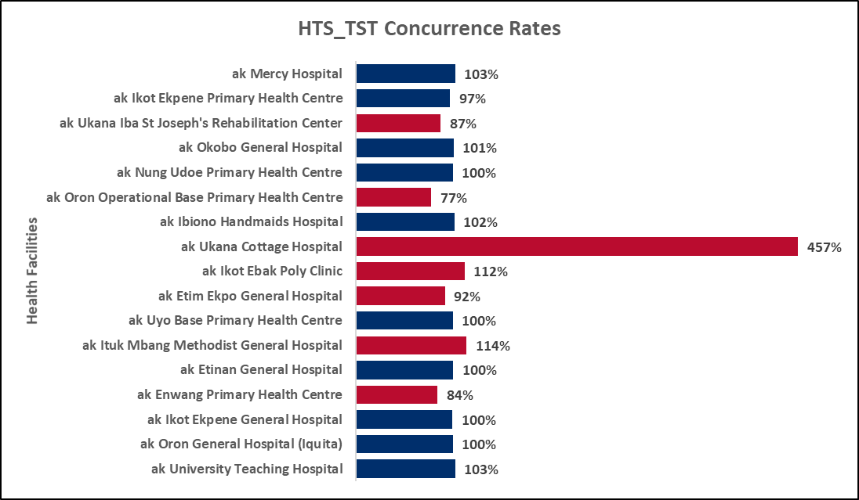

**Figure 2: Concurrence Rates for HTS_TST Positives by FHI360 SIDHAS Health Facilities**

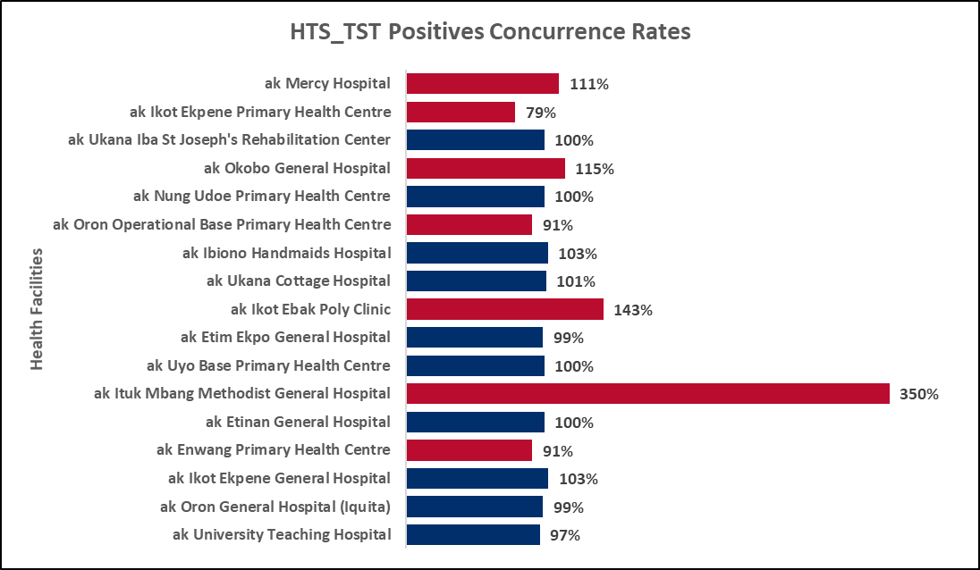

The concurrence rates for the HTS_INDEX and the HTS_INDEX Positives indicator disaggregate for each health facility supported by the FHI360/SIDHAS Activity are in Figure 3 and Figure 4 below. Two (2) and 11 of the 17 health facilities had concurrence rates within the acceptable variance range of +\- five (5) percent for the HTS_INDEX indicator and HTS_INDEX Positives indicator disaggregate respectively.

**Figure 3: Concurrence Rates for HTS_INDEX by FHI360 SIDHAS Health Facilities**

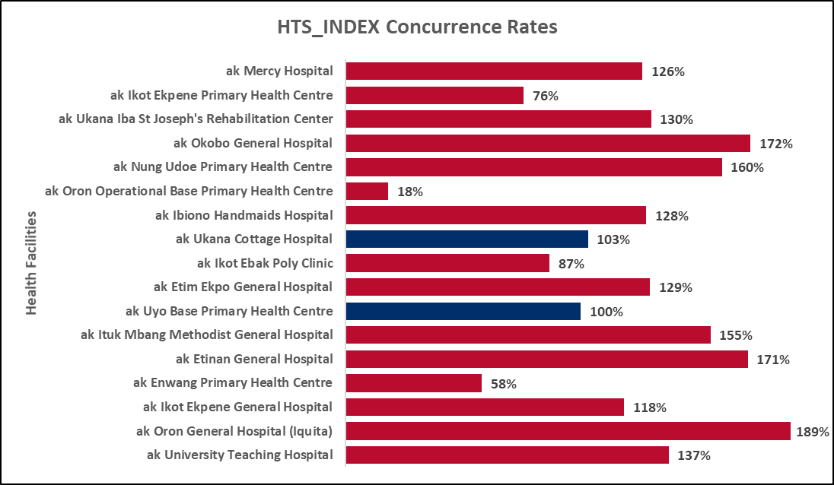

**Figure 4: Concurrence Rates for HTS_INDEX Positives by FHI360 SIDHAS Health Facilities**

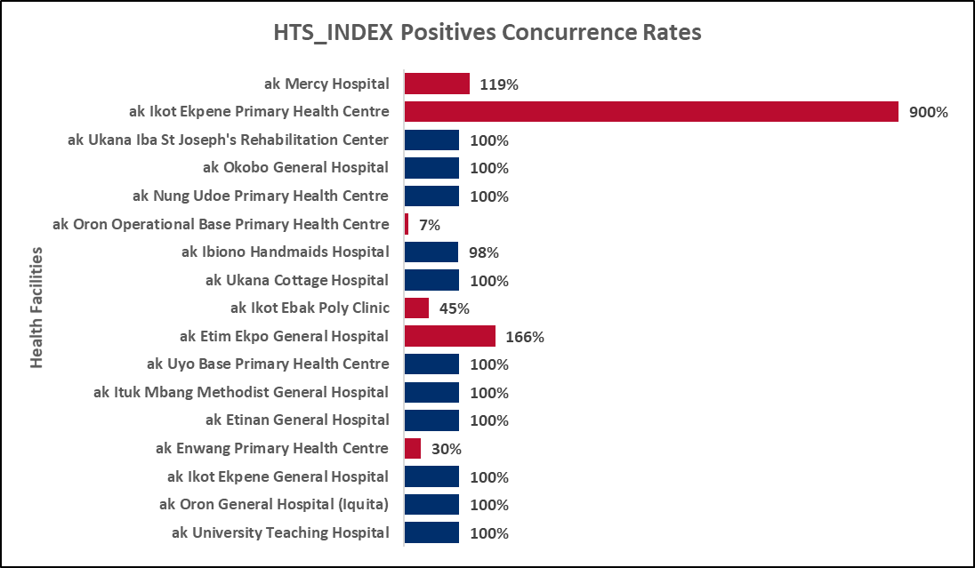

### **3.1.2 Tx_new**

The concurrence rates for the TX_NEW indicator for the 17 FHI360/SIDHAS supported health facilities are in Figure 5 below. Eleven (11) health facilities had concurrence rates within the acceptable variance range of +\- five (5) percent. Out of the remaining six (6) health facilities, three (3) significantly over-reported TX_NEW indicator data and three (3) significantly under-reported TX_NEW indicator data.

**Figure 5: Concurrence Rates for TX_NEW by FHI360 SIDHAS Health Facilities**

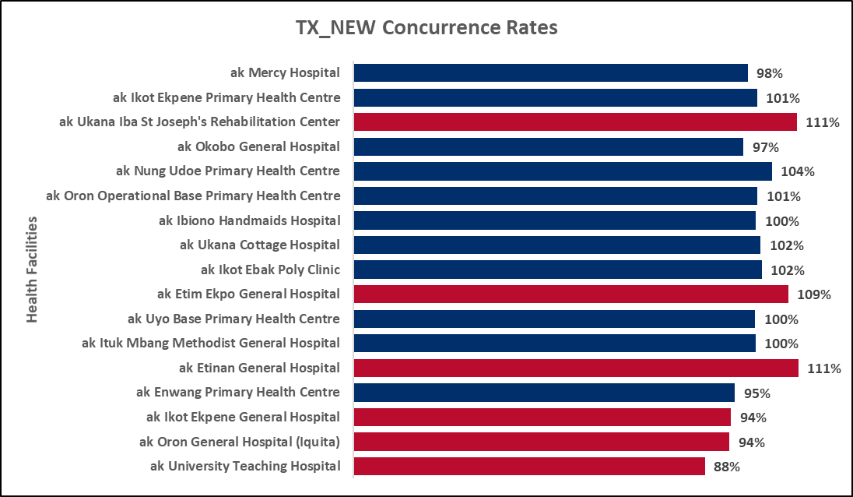

### **3.1.3 Tx_curr**

The concurrence rates for the TX_CURR indicator for all the FHI360/SIDHAS supported health facilities were within the acceptable variance range of +\- five (5) percent, except that of Enwang Primary Health Centre (Figure 6). The Enwang Primary Health Centre significantly under-reported TX_CURR indicator data.

**Figure 6: Concurrence Rates for TX_CURR by FHI360 SIDHAS Health Facilities**

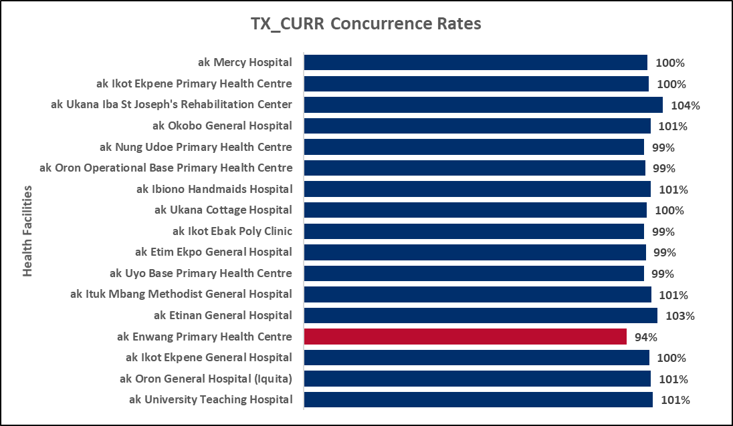

Figure 7 below gives the percentage of the validated active clients found on LAMIS for each health facility. Only five (5) health facilities had all validated active clients in LAMIS, while the remaining 12 health facilities had missing active client details which could not be found among the active client list on LAMIS.

**Figure 7: Percentage of Validated Active Clients on LAMIS by FHI360 SIDHAS Health Facilities**

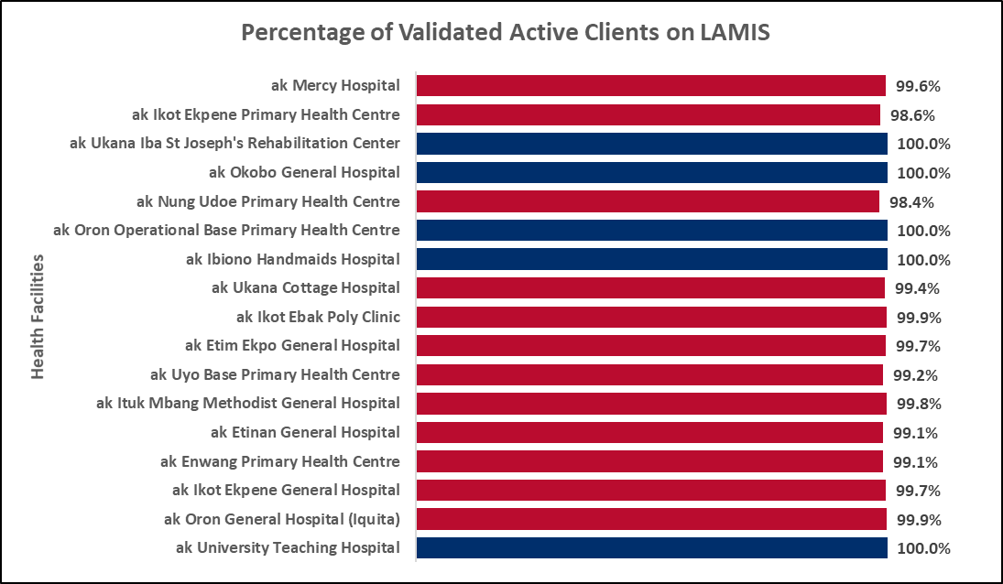

## 3.2 HEARTLAND ALLiANCE INTERNATIONAL/IMHIPP

### **3.2.1 HTS_TST (INCLUDING hts_tst_pos) AND hts_index**

The concurrence rates for the HTS_TST indicator for each LGA through which the HAI/IMHIPP Activity reports testing data on DATIM are in Figure 8 below. Thirteen (13) of the 27 LGAs had concurrence rates within the acceptable variance range of +\- five (5) percent. However, for the HTS_TST Positives indicator disaggregate, only 11 of the 27 LGAs had concurrence rates within the acceptable variance range of +\- five (5) percent (Figure 9).

**Figure 8: Concurrence Rates for HTS_TST by HAI IMHIPP LGAs**

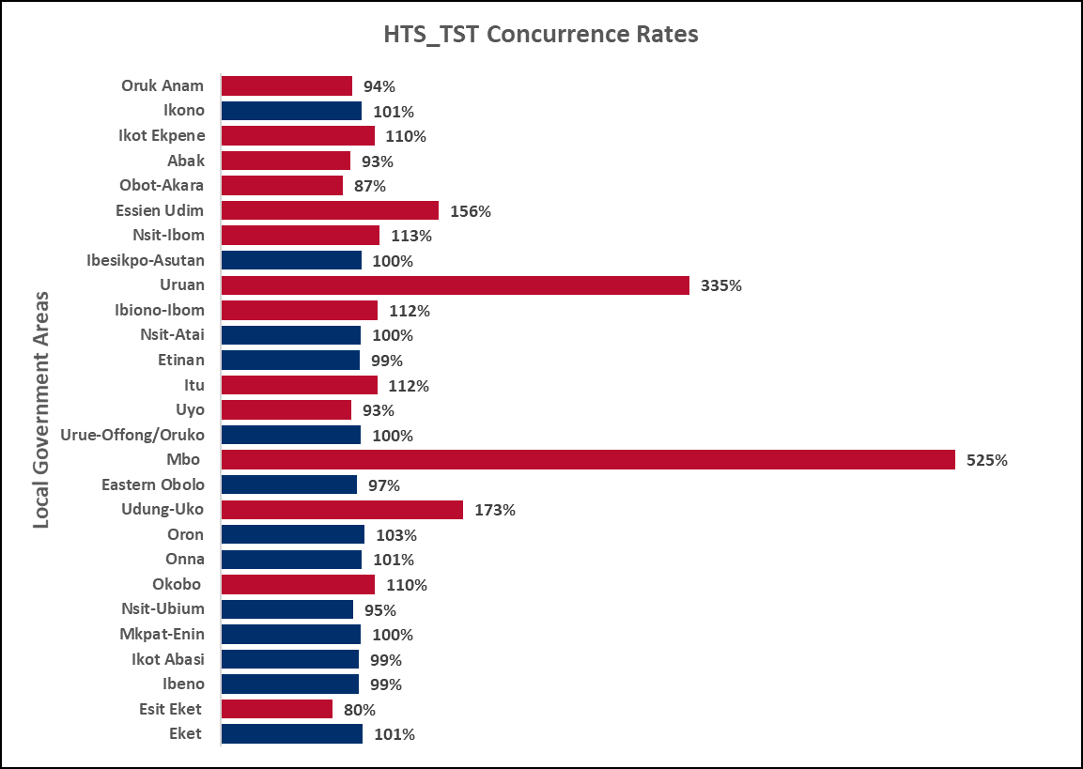

**Figure 9: Concurrence Rates for HTS_TST Positives by HAI IMHIPP LGAs**

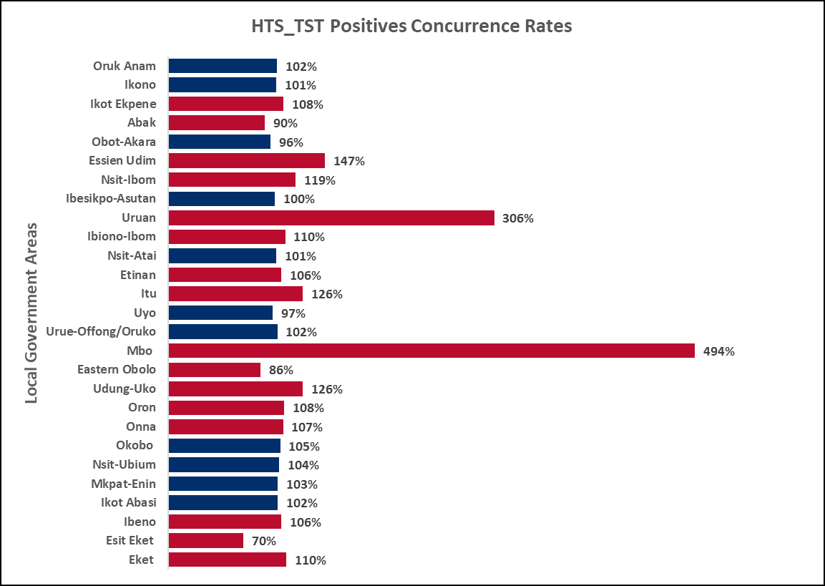

The concurrence rates for the HTS_INDEX and the HTS_INDEX Positives indicator disaggregate for each LGA through which the HAI/IMHIPP Activity reports testing data on DATIM are in Figure 10 and Figure 11 . Ten (10) and four (4) of the LGAs had concurrence rates within the acceptable variance range of +\- five (5) percent for the HTS_INDEX indicator and HTS_INDEX Positives indicator disaggregate respectively.

**Figure 10: Concurrence Rates for HTS_INDEX by HAI IMHIPP LGAs**

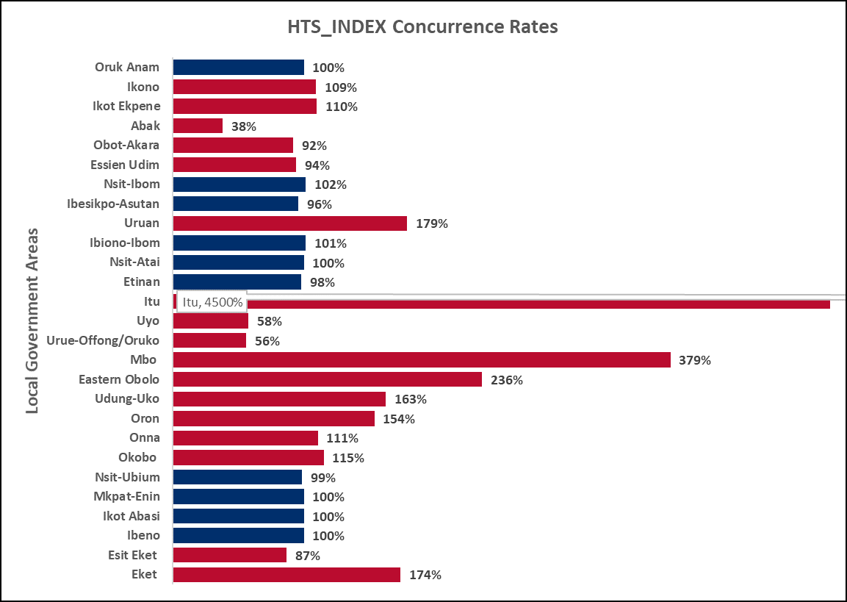

**Figure 11: Concurrence Rates for HTS_INDEX Positives by HAI IMHIPP LGAs**

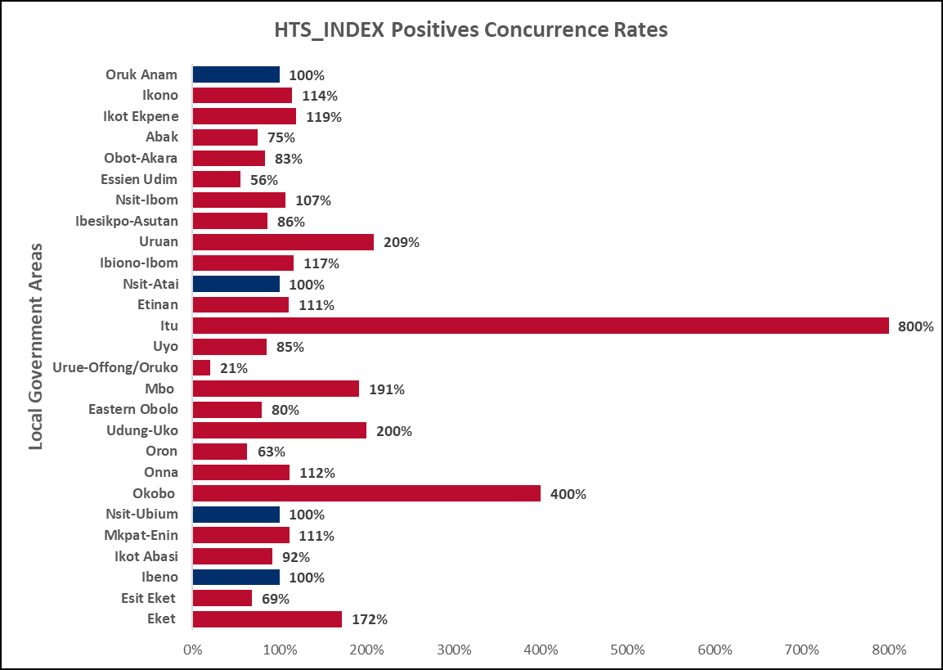

### **3.2.2 Tx_new**

The concurrence rates for the TX_NEW indicator for the two treatment sites: Uyo Heartland Alliance Community Centre and Eket Key Population OSS through which the HAI/IMHIPP Activity reports treatment data on DATIM are in Figure 12 below. Both treatment sites had concurrence rates within the acceptable variance range of +\- five percent.

**Figure 12: Concurrence Rates for TX_NEW by HAI IMHIPP Treatment Sites**

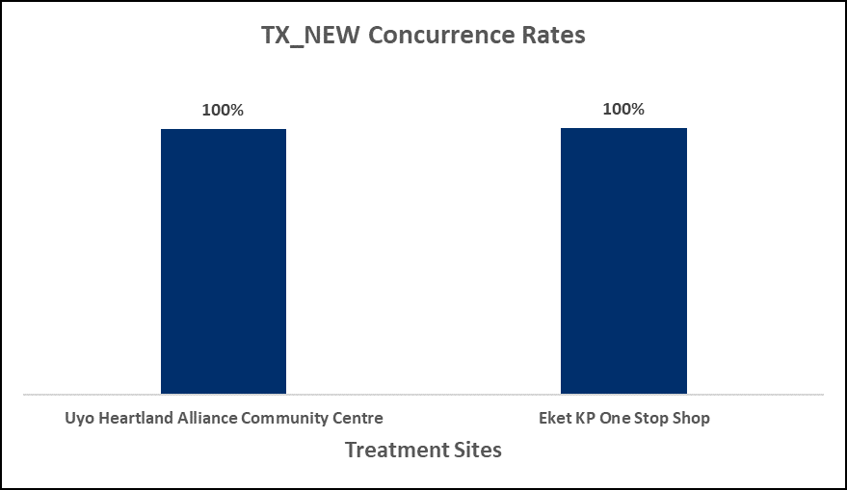

### **3.2.3 Tx_curr**

The concurrence rates for the TX_CURR indicator for the two HAI/IMHIPP treatment sites were within the acceptable variance range of +\- five percent (Figure 13).

**Figure 13: Concurrence Rates for TX_CURR by HAI IMHIPP Treatment Sites**

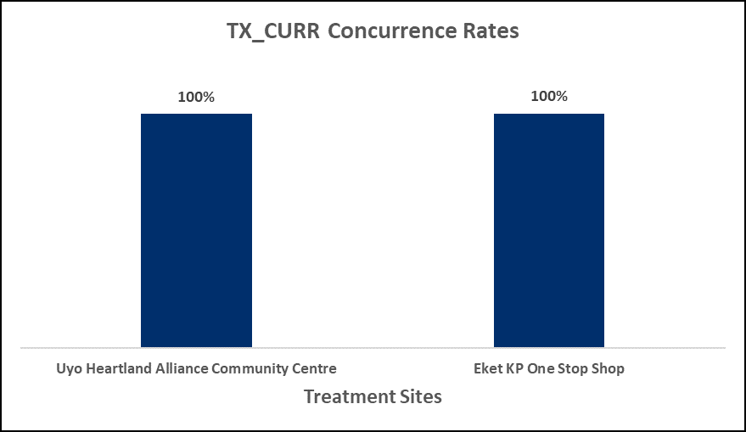

Figure 14 below gives the percentage of the validated active clients found on LAMIS for each treatment site. While all the validated active clients had records in LAMIS at the Eket KP OSS, only 98 percent of the validated active clients had records in LAMIS at the Uyo Heartland Alliance Community Centre.

**Figure 14: Percentage of Validated Active Clients on LAMIS by HAI IMHIPP Treatment Sites**

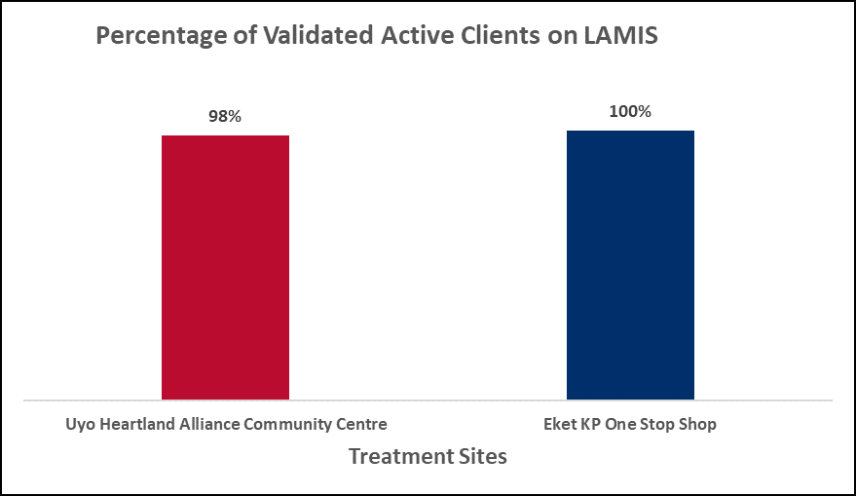

### **3.2.4 TX_PLVS (Numerator and Denominator)**

The concurrence rates for both the TX_PVLS numerator and denominator indicator disaggregates for Eket KP OSS were outside the acceptable variance range of +\- five percent. Similarly, the concurrence rate for the TX_PVLS denominator indicator disaggregate for Uyo Heartland Alliance Community Centre was also outside the acceptable variance range, as opposed to the concurrence rate for the TX_PVLS numerator disaggregate which was within the acceptable variance range. These concurrence rates are shown below in Figure 15.

**Figure 15: Concurrence Rates for TX_PVLS by HAI IMHIPP Treatment Sites**

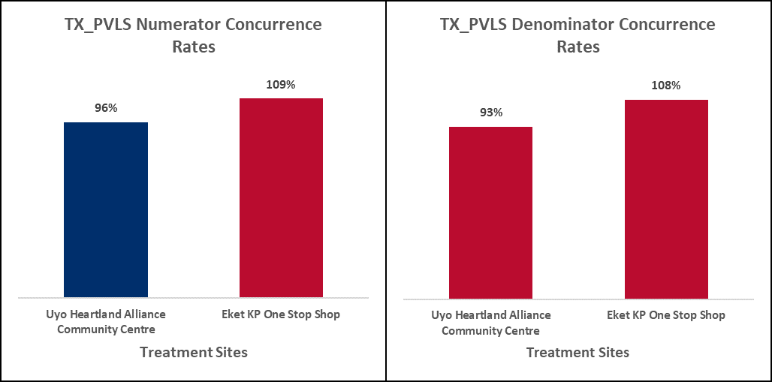

## 3.3 ARFH LOPIN 1

### **3.3.1 Number of HIV Positive in OVc Program (OVC_HIVSTAT Positives)**

The concurrence rates for the indicator disaggregate OVC_HIVSTAT Positives in the eight (8) ARFH LOPIN 1 Activity LGAs fell within the acceptable variance range of +\- five (5) percent, when the line list summary data was compared against entries on NOMIS and VC folders as illustrated in Figure 16 and Figure 17 respectively. When the line list summary data was compared against NOMIS entries, only Ibesikpo-Asutan LGA data (99 percent) was not an exact match. Furthermore, two LGAs: Ibesikpo-Asutan (99 percent) and Itu (101 percent) weren’t an exact match when the line list was validated with VC folders.

**Figure 16: Concurrence Rates (NOMIS) OVC_HIVSTAT Positives for ARFH LOPIN 1 LGAs**

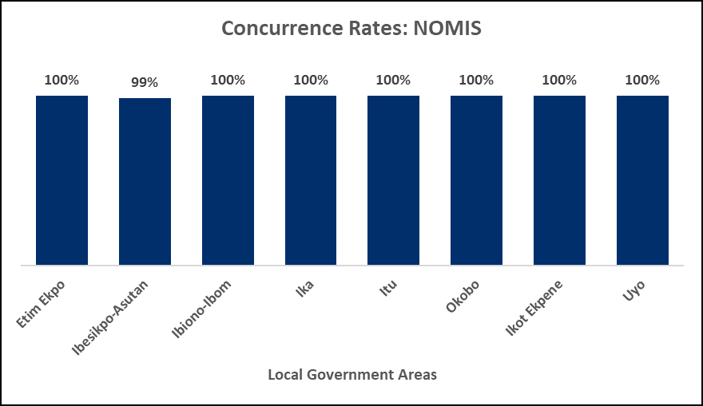

**Figure 17: Concurrence Rates (VC folders) OVC_HIVSTAT Positives for ARFH LOPIN 1 LGAs**

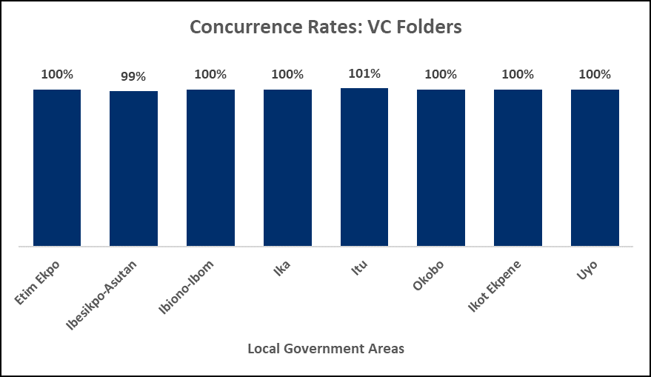

## 3.4 StC Steer

### **3.4.1 Number of HIV Positive in OVc Program (OVC_HIVSTAT Positives)**

The concurrence rates for the indicator disaggregate OVC_HIVSTAT Positives in only two: Udung-Uko and Urue-Offong/Oruko LGAs; of the fourteen STC STEER Activity LGAs fell within the acceptable variance range of +\- five (5) percent when the line list summary data was compared against entries on NOMIS (Figure 18). When the data was validated using VC folders, only concurrence rates for OVC_HIVSTAT Positives disaggregate data for the same two LGAs: Udung-Uko and Urue-Offong/Oruko LGAs; fell within the acceptable variance range of +\- five percent (Figure 19).

**Figure 18: Concurrence Rates (NOMIS) OVC_HIVSTAT Positives for STC STEER LGAs**

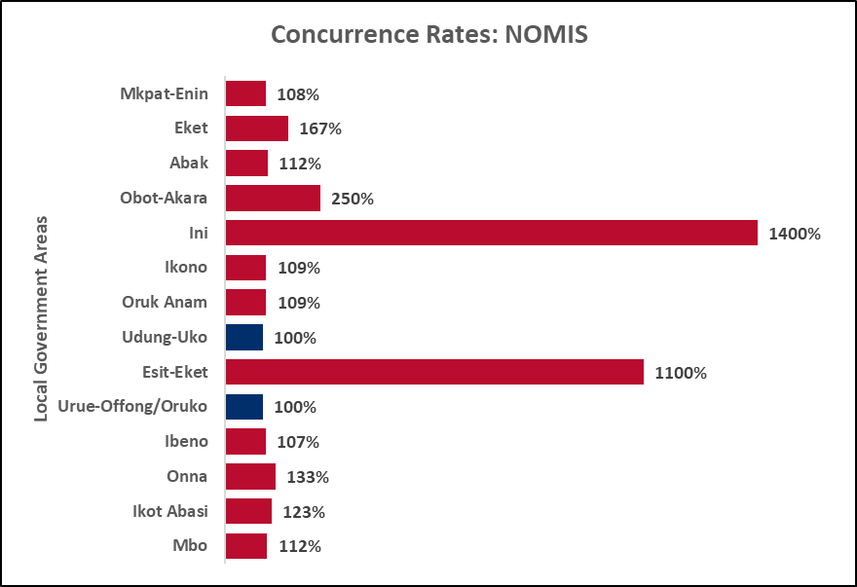

Figure 19: Concurrence Rates (VC folders) OVC_HIVSTAT Positives for STC STEER LGAs

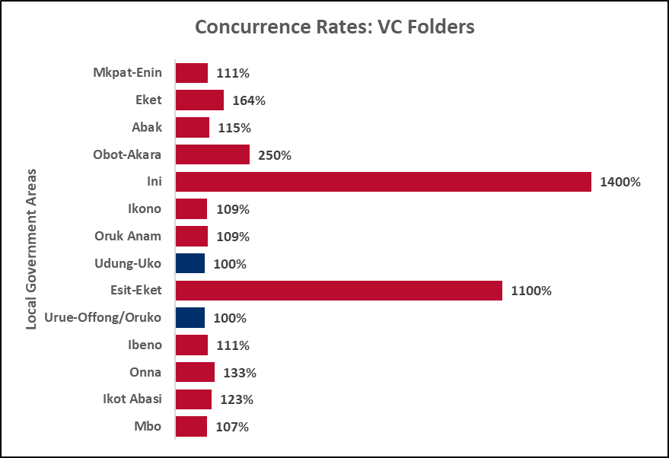

## 3.5 HIFASS LOPIN 3

### **3.5.1 Number of HIV Positive in OVc Program (OVC_HIVSTAT Positives)**

The concurrence rates for the indicator disaggregate OVC_HIVSTAT Positives in seven (7) of the eight (8) HIFASS LOPIN 3 Activity LGAs fell within the acceptable variance range of +\- five (5) percent, when the line list summary data was compared against entries on NOMIS, with Ukanafun LGA being the exception (Figure 20). However, all the eight (8) LGAs had concurrence rates within the acceptable variance range of +\- five (5) percent when indicator disaggregate data was validated with VC folders (Figure 21).

**Figure 20: Concurrence Rates (NOMIS) OVC_HIVSTAT Positives for HIFASS LOPIN 3 LGAs**

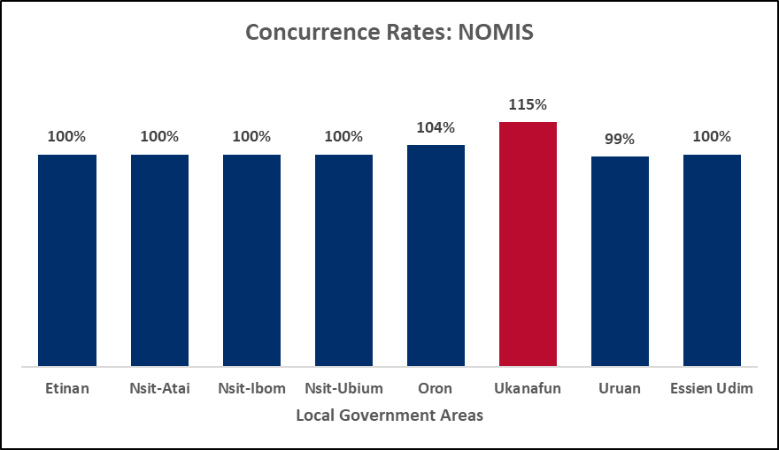

**Figure 21: Concurrence Rates (VC folders) OVC_HIVSTAT Positives for HIFASS LOPIN 3 LGAs**

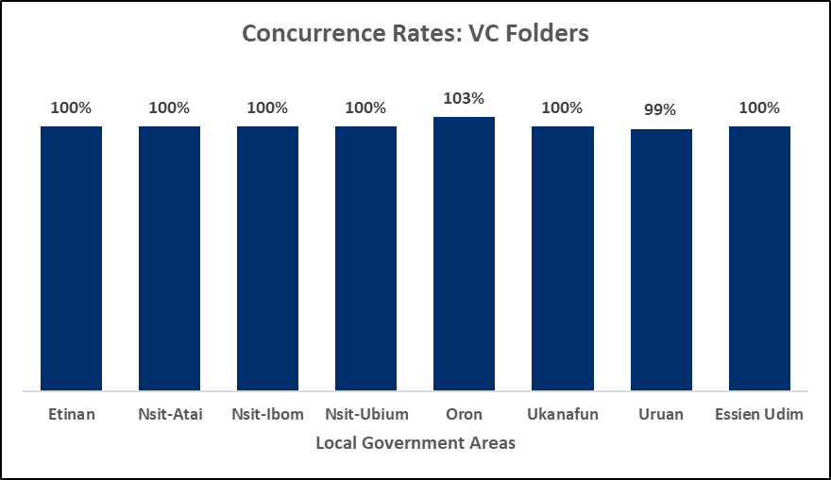

# 4. FINDings – Data quality issues

This section details the data quality issues identified relating to the indicator data audited by IP/IM.

## 4.1 FHI 360/SIDHAS

### **4.1.1 Cross Cutting Issues Across All fhi 360/sidhas Sites**

* Inconsistency in the methodology for data collection and reporting of the viral load test date across the first three FHI 360 sites visited. This resulted in USAID instructing the Data Audit team to discontinue validation of the indicator data for the other FHI 360 sites. At the FHI 360 sites, it was observed that the date used to calculate the TX PVLS data reported to USAID for the period under review is the date the test result was released from the Polymerase Chain Reaction (PCR) Lab (June 2019 date). The dates sighted in the source documents within the client folders (laboratory forms) were hand written ‘R and R dates’ - dates results were received by the facility M&E personnel who filed the Lab forms within the client folders (July 2019 dates were mostly sighted). However, not all Lab forms had the hand written ‘R and R’ date across the facilities visited. The Data Audit team also sighted dates within the viral load register that varied from the ‘R and R’ dates on the Lab forms. The dates recorded in the viral load register are the dates the facility Lab personnel received the results within the facility from the logistics riders. These dates in the viral load register precedes the ‘R and R’ date written on the Lab form by the facility M&E personnel. In some instances, the dates in the viral load register varied from the June 2019 dates reported by FHI to USAID for the TX PVLS indicator.
* No standard operating procedure (SOP) provided to the health facilities by FHI 360 to guide the movement and reporting of received viral load results within the health facility after delivery to the facility by the logistics riders.
* The most recent Lab request form containing the viral load result were not always contained within the folders.
* The most recent pharmacy order forms were not filed within the folders, resulting in validation of indicator data using the pharmacy daily worksheet (secondary source document), especially for devolved clients receiving drug refills at community pharmacies. The pharmacy worksheets were said to be domiciled and in-use within the communities. Some of the folders with missing pharmacy order forms could not be validated using the pharmacy daily worksheet because the client records were not found in the worksheet.
* Incomplete documentation of client information on the ART care card: age at ART start, sex and ART start date.
* Varying documentation of client information (age at ART start, sex and ART start dates) upon review of the ART care card, IP’s line list and the LAMIS/EMR.
* Complete absence of ART care cards within some client folders.
* Alterations were sighted on some pharmacy order forms without an authorizing signature to validate the changes.
* Pharmacy order forms were sighted without the signature of the pharmacist who dispensed the ART.

### **4.1.2 Ituk Mbang Methodist General Hospital**

* The records/folders of 12 clients of the 1,532 reported active within the period of review were not sighted for review at the time of visit.
* The records of 21 clients reported active within the period of review were found inactive upon review of source documents.
* Records of nine (9) active clients not in the IP’s line list were seen, reviewed and captured within the data audit tool.
* During the mop-up site visits, folders previously pending review/not seen during the first visit to the site, were presented for review as new folders containing a few patient monitoring and management (PMM) forms for clients that have been active for a considerable number of years. These folders were termed ‘temporary folders’.

### **4.1.3 Uyo Base Primary Health Care**

* The records/folders of three (3) clients of the 1,492 reported active within the period of review were not sighted for review at the time of visit.
* The records of 14 clients reported active within the period of review were found inactive upon review of source documents.
* Records of 22 active clients not in the IP’s line list were seen, reviewed and captured within the data audit tool.

### **4.1.4 Mercy Hospital**

* The folder of one (1) client of the 745 reported active within the period of review was not sighted for review at the time of visit.
* The records of eight (8) clients reported active within the period of review were found inactive upon review of source documents.

### **4.1.5 Ikot Ekpene General Hospital**

* The records/folders of eight (8) clients of the 2,352 reported active within the period of review were not sighted for review at the time of visit.
* The records of 24 clients reported active within the period of review were found inactive upon review of source documents.
* Records of 11 active clients not in the IP’s line list were seen, reviewed and captured within the data audit tool.
* Multiple ART care cards were seen within the same folders, often with varying age and ART start dates recorded on each of the cards.
* Five (5) clients observed to be transferred into care at the facility in the month of July 2019, were wrongly reported as actively receiving care within the facility as at end of June 2019.

### **4.1.6 Oron Operational Base Primary Health Centre**

* The records/folders of two (2) clients of the 1,007 reported active within the period of review were not sighted for review at the time of visit.
* The records of five (5) clients reported active within the period of review were found inactive upon review of source documents.
* Records of nine (9) active clients not in the IP’s line list were seen, reviewed and captured within the data audit tool.

### **4.1.7 Enwang Primary Health Centre**

* The records/folders of 21 clients of the 1,723 reported active within the period of review were not sighted for review at the time of visit.
* The records of 31 clients reported active within the period of review were found inactive upon review of source documents.
* Records of 111 active clients not in the IP’s line list were seen, reviewed and captured within the data audit tool. These 111 clients were majorly devolved clients who receive drug refills within the community but have records domiciled in the health facility. The client records were not brought to the facility on time to be captured with the TX_CURR data reported for FY 2019 Q3.
* Inconsistency between the number of active clients on the IP’s line list and the number of active clients in the EMR/LAMIS at the facility.
* Transcription errors observed between the unique ID written on the client folder and the unique ID on the IP’s line list and the LAMIS line list.
* A client with unique ID AKS/006/0524 was observed to have two folders with different ART start dates and last drug pick up dates; May 18, 2019 with last pick up date as June 18, 2019 on one folder and May 19, 2019 with last pick up date as June 13, 2019.

### **4.1.8 Ikot Ebak Poly Clinic**

* The records/folders of four (4) clients of the 1,104 reported active within the period of review were not sighted for review at the time of visit.
* The records of five (5) clients reported active within the period of review were found inactive upon review of source documents.
* Records of 18 active clients not in the IP’s line list were seen, reviewed and captured within the data audit tool.

### **4.1.9 University Teaching Hospital**

* The records/folders of 55 clients of the 3,906 reported active within the period of review were not sighted for review at the time of visit.
* The records of four (4) clients reported active within the period of review were found inactive upon review of source documents.
* Records of 84 active clients not in the IP’s line list were seen, reviewed and captured within the data audit tool.
* During the mop-up site visits, folders previously pending review/not seen during the first visit to the site, were presented for review as new folders containing a few PMM forms for clients that have been active for a considerable number of years. These folders were termed ‘temporary folders’.

### **4.1.10 Oron General Hospital (Iquita)**

* The records/folders of 47 clients of the 3,582 reported active within the period of review were not sighted for review at the time of visit.
* The records of five (5) clients reported active within the period of review were found inactive upon review of source documents.
* Records of 24 active clients not in the IP’s line list were seen, reviewed and captured within the data audit tool.
* During the mop-up site visits, 22 folders previously pending review/not seen during the first visit to the site, were presented for review as new folders containing a few PMM forms for clients that have been active for a considerable number of years. These folders were termed ‘temporary folders.’ It was explained that the recent renovations at the hospital resulted in the movement of client records to a different storage space, which made it difficult to retrieve the actual folders.
* Some active clients on the IP’s line list were not found on the line list generated from the LAMIS for the period under review.
* Two client folders were seen to have the same client name, sex, address and age, but different unique IDs and ART start dates (003/UYY/00367, September 27, 2016 and 033/UYO/00367, September 28, 2019).

### **4.1.11 Etim Ekpo General Hospital**

* The records/folders of 12 clients of the 1,192 reported active within the period of review were not sighted for review at the time of visit.
* The records of three (3) clients reported active within the period of review were found inactive upon review of source documents.
* Records of 22 active clients not in the IP’s line list were seen, reviewed and captured within the data audit tool.

### **4.1.12 Ukana Cottage Hospital**

* The folder of 1 client of the 1,087 reported active within the period of review was not sighted for review at the time of visit.
* The records of one (1) client reported active within the period of review was found inactive upon review of source documents.
* Records of five (5) active clients not in the IP’s line list were seen, reviewed and captured within the data audit tool.
* About 30 folders of active clients within this facility had no ART care card. The ART care cards were filled and filed during the audit using photocopied ART care cards and data from the LAMIS. It was explained that the facility ran out of ART care cards at some point resulting in the non-availability of ART care cards in some of the folders.

### **4.1.13 Etinan General Hospital**

* The records/folders of 64 clients of the 1,662 reported active within the period of review were not sighted for review at the time of visit.
* The records of 52 clients reported active within the period of review were found inactive upon review of source documents.
* Records of 70 active clients not in the IP’s line list were seen, reviewed and captured within the data audit tool.

### **4.1.14 Ibiono Handsmaid Hospital**

* The records/folders of eight (8) clients of the 1,023 reported active within the period of review were not sighted for review at the time of visit.
* The records of four (4) clients reported active within the period of review were found inactive upon review of source documents.
* Records of three (3) active clients not in the IP’s line list were seen, reviewed and captured within the data audit tool.

### **4.1.15 Nung Udoe Primary Health Centre**

* The records/folders of five (5) clients of the 863 reported active within the period of review were not sighted for review at the time of visit.
* The records of two (2) clients reported active within the period of review were found inactive upon review of source documents.
* Records of 16 active clients not in the IP’s line list were seen, reviewed and captured within the data audit tool.

### **4.1.16 Ukana Iba St Joseph's Rehabilitation Center**

* The records/folders of 14 clients of the 791 reported active within the period of review were not sighted for review at the time of visit.
* The records of 22 clients reported active within the period of review were found inactive upon review of source documents.
* Records of three (3) active clients not in the IP’s line list were seen, reviewed and captured within the data audit tool.

### **4.1.17 Okobo General Hospital**

* The records/folders of five (5) clients of the 794 reported active within the period of review were not sighted for review at the time of visit.
* The record of one (1) client reported active within the period of review was found to be inactive upon review of source documents.
* The record of one (1) active client not in the IP’s line list was seen, reviewed and captured within the data audit tool.

### **4.1.18 Ikot Ekpene Primary Health Centre**

* The records/folders of seven (7) clients of the 773 reported active within the period of review were not sighted for review at the time of visit.
* The records of six (6) clients reported active within the period of review were found inactive upon review of source documents.
* Records of 11 active clients not in the IP’s line list were seen, reviewed and captured within the data audit tool.

## 4.2 HEARTLAND ALliaNCE INTERNATIONAL/IMHIPP

### **4.2.1 Cross Cutting Issues Across All hai/imhipp oss**

* Inconsistency in the methodology for data collection and reporting of the viral load test date. The Uyo OSS and the Ikot Ekpene OSS calculate data for the reported TX PVLS using the date at the bottom of the Lab form, which is the date the test result was released from the PCR lab. The Eket OSS on the other hand calculates reported TX PVLS data using the date documented in the viral load register, which is the date the test result arrived at the facility. This date is not documented anywhere on the primary source documents (the Lab request forms) within the client folders.
* No SOP provided to the OSS by HAI to guide the movement and reporting of received viral load results within the OSS after delivery to the sites by the logistics riders.
* The outdated version of the HTS register was in use at all the HAI OSS sites visited. The outdated version of the HTS register has different age disaggregations by sex (1-4, 5-9, 10-14, 15-19, 20-24, 25-49, 50+) from the updated version of the HTS register (<1, 1-4, 5-9, 10-14, 15-19, 20-24, 25-29, 30-34, 35-39, 40-44, 45-49, 50-64, 65+). HTS data is reported to USAID by HAI using the disaggregations in the updated HTS register despite use of the outdated HTS register for data collection, increasing the likelihood for error in age disaggregation reporting for the HTS indicator.

### **4.2.2 Uyo OSS**

* The records/folders of three (3) clients of the 2,505 reported active within the period of review were not sighted for review at the time of visit.
* The records of nine (9) clients reported active within the period of review were found inactive upon review of source documents.
* Records of 18 active clients not in the IP’s line list were seen, reviewed and captured within the data audit tool.

### **4.2.3 Ikot Ekpene oss**

* The records of 11 clients of the 1,671 reported active within the period of review were found inactive upon review of source documents.
* Records of 12 active clients not in the IP’s line list were seen, reviewed and captured within the data audit tool.

### **4.2.4 Eket oss**

* The records/folders of two (2) clients of 2,274 reported active within the period of review were not sighted for review at the time of visit.
* The records of 24 clients reported active within the period of review were found inactive upon review of source documents.
* Records of 31 active clients not in the IP’s line list were seen, reviewed and captured within the data audit tool.
* Few cases with varying documentation of client information (age at ART start, sex and ART start dates) upon review of the ART care card and IP’s line list.
* A few pharmacy order forms were sighted without the signature of the pharmacist who dispensed the ART and without the date the ART was dispensed.
* In a few instances, the pharmacy order form was entirely missing from the folder, necessitating validation with the pharmacy daily worksheet.
* Difficultly validating the last drug refill date using the pharmacy daily worksheet because the unique ID and hospital number of clients are not documented in the worksheet. The client’s name and date of last clinic visit are the only identifiers that can be used to validate the last drug refill date and quantity dispensed within the worksheet.

## 4.3 OVC PARTNERS

### **4.3.1 Cross Cutting Issues Across All Three OVC Partners**

* The reporting interface of NOMIS appears to be defective because data with varying information on the HIV_STAT_POS indicator were generated via two different reporting sections of the NOMIS at the time of visit. This observation was observed also at ARFH LOPIN 1 office where the most updated version of NOMIS was in use (version 5.9). Due to the defective reporting interface of NOMIS, the line list generated from the NOMIS at the IP offices at the time of visit varied from the line list shared with the Data Audit team before the audit. The variance observed include the ART treatment status and service status of beneficiaries.
* The ART treatment status was not always updated on the service forms. Treatment status had to be established by the presence of the returned copy of the client referral form from a treatment facility.
* Various interfaces on NOMIS capture dates differently. Both the mm/dd/yy and dd/mm/yy date formats are in use on the NOMIS, increasing the likelihood for data entry errors relating to date last served and other dates that are captured on the system.
* Discrepancies were observed between the age and sex documented in the folders and the age and sex documented on the IP’s line list and NOMIS due to transcription errors during data entry. E.g. a male client as seen within the folder can be captured in error as female on the NOMIS or vice versa; and a seven-month-old client was seen captured as seven years old on the NOMIS.

### **4.3.2 ARFH LOPIN 1**

* Upon review of relevant source documents, one (1) client (in Itu LGA) reported as OVC HIVSTAT POS within the period of review was enrolled and served in July 2019.
* The record of one (1) OVC HIVSTAT POS client from Ibesikpo LGA not on the IP’s line list was seen, reviewed and captured within the data audit tool.

### **4.3.3 STC STEER**

* The records/folders of three (3) clients (Eket LGA) of the 87 reported as OVC HIVSTAT POS within the period of review were not sighted for review at the time of visit.
* Upon review of relevant source documents, 115 clients (from all 14 LGAs) reported as OVC HIVSTAT POS within the period of review were enrolled and served in July 2019.
* The record of one (1) OVC HIVSTAT POS client from Orukanam LGA not on the IP’s line list was seen, reviewed and captured within the data audit tool.
* Transcription errors observed within the source documents; the records of a client in Mbo LGA was observed to have July 18, 2019 as the date of enrollment and June 1, 2019 as the date of last service.
* Two VC, one from Abak LGA (AKW/AAK/SCI/HH00011/VC00001) and another from Onna LGA (AKW/NNA/SCI/HH00057/VC00001) were found upon review of the folders to both be 20 years old, outside the specified reporting age for the OVC_HIVSTAT positives indicator disaggregate. The premise on which these two were reported among the OVC HIVSTAT POS for FY2019 Q3 was that they are both still in secondary school. It was also observed that the VC in Abak LGA was captured on the NOMIS as being 17years old while the VC in Onna LGA was not found on the NOMIS and was served in July 2019 and not within the review period.
* Three (3) clients in Eket LGA were observed to have outlying ages on the line list shared with the Data Audit team by the IP before the visit. The ages were 42, 43 and 44 years, as seen in the picture below.

**Figure 22: Picture Showing Age Outliers in the OVC HIVSTATPOS FY 2019 Q3 Line List From the IP**

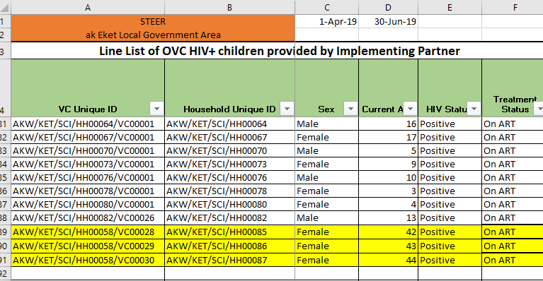

### **4.3.4 HIFASS LOPIN 3**

* The records/folders of one (1) client (in Uruan LGA) of 107, and eight (8) clients (in Oron LGA) of 122 reported as OVC HIVSTAT POS within the period of review were not sighted for review at the time of visit.
* Upon review of relevant source documents, three (3) clients (in Uruan LGA) reported as OVC HIVSTAT POS within the period of review were enrolled and served in July 2019.
* The records of nine (9) OVC HIVSTAT POS clients from Oron LGA (4) and Uruan LGA (5), not on the IP’s line list were seen, reviewed and captured within the data audit tool.
* The unique IDs of VC within the same household were being used interchangeably (seen within the folder and on NOMIS). Hence, data for a particular VC can be seen captured on the NOMIS or service form using the unique ID of the sibling.

# 5. RECOMMENDATIONS

## 5.1 usaid NIGERIA

* Provide guidance to HIV care and treatment partners (FHI 360 and HAI) to standardize reporting on the TX PVLS indicator.
* Recruit a team of experts to fix the bugs within the OVC EMR reporting system (NOMIS).

## 5.2 FHI 360

* Develop a SOP to guide the reporting of the TX PVLS indicator, disseminate same to all reporting levels.
* Develop a SOP to guide the timely filing of pharmacy order forms in the client folders, especially for devolved clients who obtain their medication within community facilities but their health records are domiciled in the health facility.
* Conduct routine internal data audit exercises to detect and remediate issues relating to data transcription errors from client folder to LAMIS, missing client folders, use of temporary client folders, alterations on source documents without an authorizing signature and incompletely and inaccurately filled PMM tools.
* Ensure careful data entry and compilation of monthly summaries of HTS data (HTS_TST and HTS_INDEX).

## 5.3 HAI

* Develop a SOP to guide the reporting of the TX PVLS indicator, disseminate same to all reporting levels.
* Commence use of the updated version of the HTS register to reduce the likelihood of errors in age-disaggregate reporting for the HTS TST indicator.
* Ensure careful data entry and compilation of monthly summaries of HTS data (HTS_TST and HTS_INDEX).

## 5.4 OVC PARTNERS

* Intensify supportive supervision of data entry clerks, especially for OVC partners who implement through CBOs (HIFASS and STEER), to reduce transcription errors on the primary source documents and on NOMIS.
* USAID reported data captured from the weekly reports of the community volunteers and/or CBOs should be documented accurately in the beneficiary folders and NOMIS. E.g. if a client was served in June 2019 but the documentation/filing was in July 2019, service date should be documented as June 2019 and not July 2019.

# 6. CONSTRAINTS AND LIMITATIONS

* Due to logistics reasons, the planned 86 percent of the TX_CURR reported figures for FHI 360 could not be audited. Only 60 percent of the total TX_CURR reported figures were audited.
* Notification of an impending data audit can cause stress for an IP given the ramifications of program performance and the potential uncertainty of USAID’s actions based on the outcome of the audit. The Data Audit team experienced a considerable amount of apprehension from the FHI 360 team during the site visits, some of which the Data Audit team tried to address in continuous dialogue with the partner to ensure a smooth exercise.

# 7. ANNEX

## 7.1 PEPFAR MER 2.0 INDICATOR REFERENCE GUIDE VERSION 2.3 SEPTEMBER 2018

Note: The PIRS for the indicators audited as detailed in the PEPFAR MER 2.0 Indicator Reference Guide Version 2.3 (September 2018) are provided below as embedded files. Please double-click the relevant file icon below to open the file; it will open in a separate window in the default program associated with the file (e.g., Adobe Reader, Adobe Acrobat, Internet Explorer, Microsoft Word, etc.).

 

## 7.2 HIV Data Audit results

Note: The embedded file provides summary data for all the indicators audited for each IP/IM. Please double-click the file icon below to open the file; it will open in a separate window in the default program associated with the file (Microsoft Excel).



## 7.3 PICTURES SHOWING DATA QUALITY ISSUES AT FHI 360 SITES

**Figure 23: Incomplete documentation on the ART Care Cards**

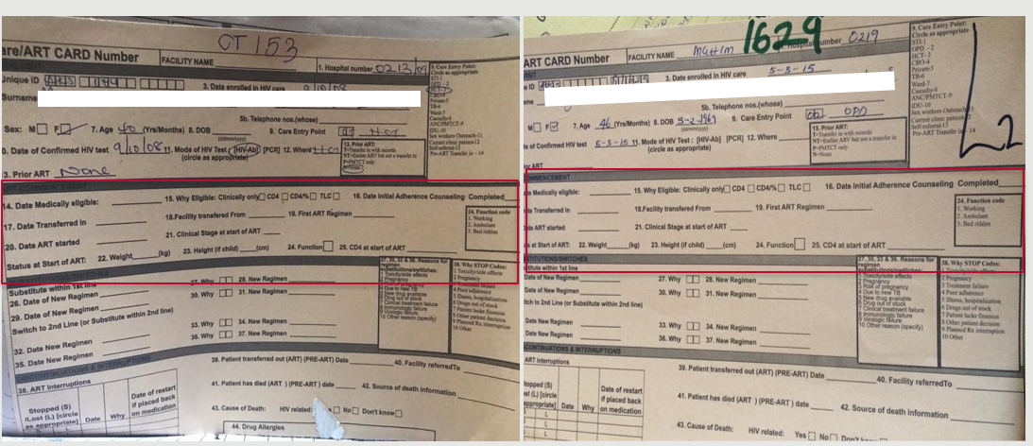

**Figure 24: Pharmacy order forms without the signature of the pharmacist who dispensed the ART**

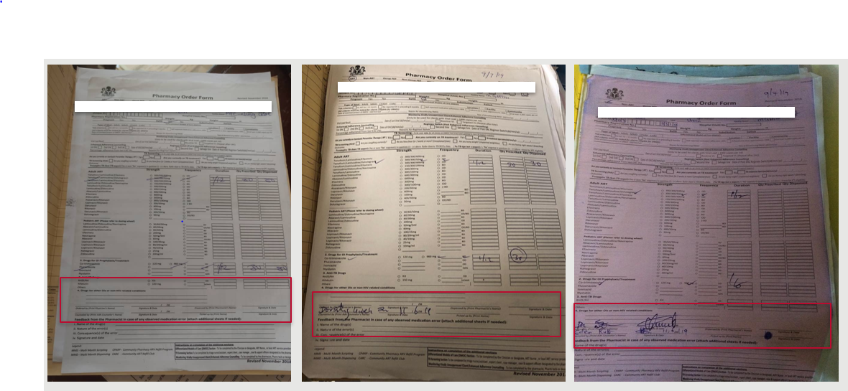

**Figure 25: Alterations on pharmacy order forms without an authorizing signature to validate the changes**

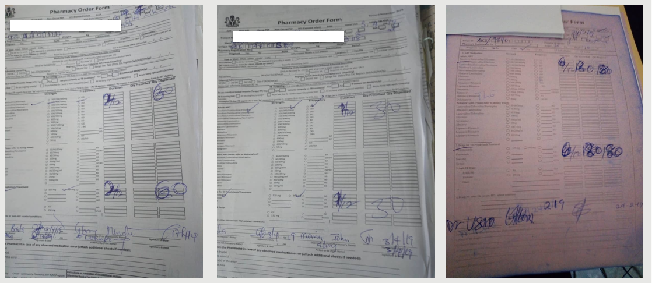

**Figure 26:Date alterations on the pharmacy order form and client folder to reflect the status of an active client with no authorizing signature to validate the changes (29/7/19 changed to 29/6/19)**

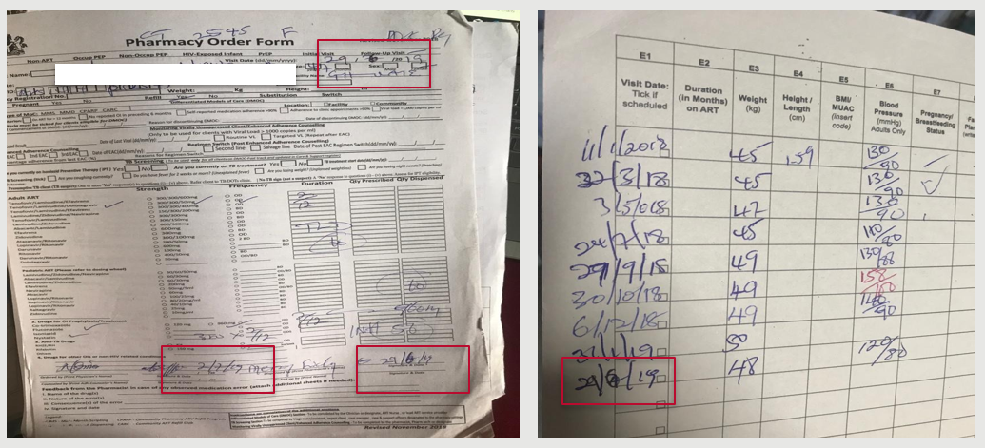

**Figure 27:Temporary folders seen at some health facilities (22 were sighted in GH Oron)**

